**January -5, 2018**

**30 Amazing Machine Learning Projects for the Past Year (v.2018)**

**For the past year**, we’ve compared nearly 8,800 open source Machine Learning projects to pick Top 30 (0.3% chance).

This is an extremely competitive list and it carefully picks the best open source Machine Learning libraries, datasets and apps published between January and December 2017. [Mybridge AI](https://www.mybridge.co) evaluates the quality by considering popularity, engagement and recency. To give you an idea about the quality, the average number of **Github stars is 3,558.**

* **Python** Projects of the Year (avg. 3,707 ⭐️): [**Here**](https://goo.gl/M2bLVE) *(0 duplicate)*
* Learn Machine Learning from Top Articles for the Past Year: [**Here**](https://goo.gl/GLdu6r) *(0 duplicate)*

Open source projects can be useful for data scientists. You can learn by reading the source code and build something on top of the existing projects. Give a plenty of time to play around with Machine Learning projects you may have missed for the past year.



<Recommended Learning>

[A) Neural Networks](http://bit.ly/2CH1WcQ)

[[](http://bit.ly/2CH1WcQ)](http://bit.ly/2CH1WcQ)

[Deep Learning A-Z™: Hands-On Artificial Neural Networks](http://bit.ly/2CH1WcQ)

[68,745 recommends, 4.5/5 stars]

[B) TensorFlow](http://bit.ly/2EatVy7)

[[](http://bit.ly/2EatVy7)](http://bit.ly/2EatVy7)

[Complete Guide to TensorFlow for Deep Learning with Python](http://bit.ly/2EatVy7)

[17,834 recommends, 4.6/5 stars]



*(Click the numbers below. Credit given to the biggest contributor.)*

[**No 1**](https://goo.gl/VWGfCs)

FastText: Library for fast text representation and classification. **[11786 stars on Github]**. Courtesy of [Facebook Research](https://medium.com/@FBResearch)

[[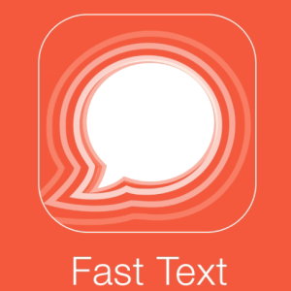](https://goo.gl/bM55cu)](https://goo.gl/bM55cu)

……….. [ [Muse](https://goo.gl/stbhjZ): Multilingual Unsupervised or Supervised word Embeddings, based on Fast Text. 695 stars on Github]

[**No 2**](https://github.com/luanfujun/deep-photo-styletransfer?utm_source=mybridge&utm_medium=blog&utm_campaign=read_more)

Deep-photo-styletransfer: Code and data for paper “Deep Photo Style Transfer” **[9747 stars on Github]**. Courtesy of Fujun Luan, Ph.D. at Cornell University

[[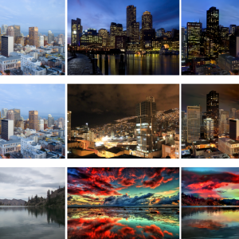](https://github.com/luanfujun/deep-photo-styletransfer?utm_source=mybridge&utm_medium=blog&utm_campaign=read_more)](https://github.com/luanfujun/deep-photo-styletransfer?utm_source=mybridge&utm_medium=blog&utm_campaign=read_more)

[**No 3**](https://github.com/ageitgey/face_recognition?utm_source=mybridge&utm_medium=blog&utm_campaign=read_more)

The world’s simplest facial recognition api for Python and the command line **[8672 stars on Github]**. Courtesy of [Adam Geitgey](https://medium.com/@ageitgey)

[[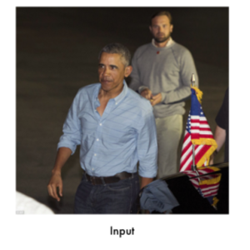](https://github.com/ageitgey/face_recognition?utm_source=mybridge&utm_medium=blog&utm_campaign=read_more)](https://github.com/ageitgey/face_recognition?utm_source=mybridge&utm_medium=blog&utm_campaign=read_more)

[**No 4**](https://github.com/tensorflow/magenta?utm_source=mybridge&utm_medium=blog&utm_campaign=read_more)

Magenta: Music and Art Generation with Machine Intelligence **[8113 stars on Github]**.

[[](https://github.com/tensorflow/magenta?utm_source=mybridge&utm_medium=blog&utm_campaign=read_more)](https://github.com/tensorflow/magenta?utm_source=mybridge&utm_medium=blog&utm_campaign=read_more)

[**No 5**](https://github.com/deepmind/sonnet?utm_source=mybridge&utm_medium=blog&utm_campaign=read_more)

Sonnet: TensorFlow-based neural network library **[5731 stars on Github]**. Courtesy of [Malcolm Reynolds](https://medium.com/@malcolm.reynolds) at Deepmind

[[](https://github.com/deepmind/sonnet?utm_source=mybridge&utm_medium=blog&utm_campaign=read_more)](https://github.com/deepmind/sonnet?utm_source=mybridge&utm_medium=blog&utm_campaign=read_more)

[**No 6**](https://github.com/PAIR-code/deeplearnjs?utm_source=mybridge&utm_medium=blog&utm_campaign=read_more)

deeplearn.js: A hardware-accelerated machine intelligence library for the web **[5462 stars on Github]**. Courtesy of Nikhil Thorat at Google Brain

[[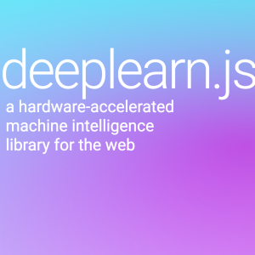](https://github.com/PAIR-code/deeplearnjs?utm_source=mybridge&utm_medium=blog&utm_campaign=read_more)](https://github.com/PAIR-code/deeplearnjs?utm_source=mybridge&utm_medium=blog&utm_campaign=read_more)

[**No 7**](https://github.com/lengstrom/fast-style-transfer?utm_source=mybridge&utm_medium=blog&utm_campaign=read_more)

Fast Style Transfer in TensorFlow **[4843 stars on Github]**. Courtesy of [Logan Engstrom](https://medium.com/@loganengstrom) at MIT

[[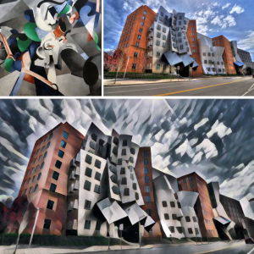](https://github.com/lengstrom/fast-style-transfer?utm_source=mybridge&utm_medium=blog&utm_campaign=read_more)](https://github.com/lengstrom/fast-style-transfer?utm_source=mybridge&utm_medium=blog&utm_campaign=read_more)

[**No 8**](https://github.com/deepmind/pysc2?utm_source=mybridge&utm_medium=blog&utm_campaign=read_more)

Pysc2: StarCraft II Learning Environment **[3683 stars on Github]**. Courtesy of Timo Ewalds at DeepMind

[[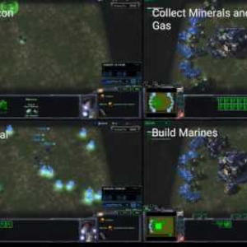](https://github.com/deepmind/pysc2?utm_source=mybridge&utm_medium=blog&utm_campaign=read_more)](https://github.com/deepmind/pysc2?utm_source=mybridge&utm_medium=blog&utm_campaign=read_more)

[**No 9**](https://github.com/Microsoft/AirSim?utm_source=mybridge&utm_medium=blog&utm_campaign=read_more)

AirSim: Open source simulator based on Unreal Engine for autonomous vehicles from Microsoft AI & Research **[3861 stars on Github]**. Courtesy of [Shital Shah](https://medium.com/@sytelus) at Microsoft

[[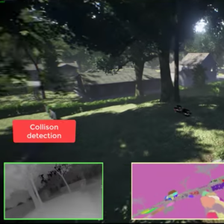](https://github.com/Microsoft/AirSim?utm_source=mybridge&utm_medium=blog&utm_campaign=read_more)](https://github.com/Microsoft/AirSim?utm_source=mybridge&utm_medium=blog&utm_campaign=read_more)

[**No 10**](https://github.com/PAIR-code/facets?utm_source=mybridge&utm_medium=blog&utm_campaign=read_more)

Facets: Visualizations for machine learning datasets **[3371 stars on Github]**. Courtesy of Google Brain

[[](https://github.com/PAIR-code/facets?utm_source=mybridge&utm_medium=blog&utm_campaign=read_more)](https://github.com/PAIR-code/facets?utm_source=mybridge&utm_medium=blog&utm_campaign=read_more)

[**No 11**](https://github.com/lllyasviel/style2paints?utm_source=mybridge&utm_medium=blog&utm_campaign=read_more)

Style2Paints: AI colorization of images **[3310 stars on Github]**.

[[](https://github.com/lllyasviel/style2paints?utm_source=mybridge&utm_medium=blog&utm_campaign=read_more)](https://github.com/lllyasviel/style2paints?utm_source=mybridge&utm_medium=blog&utm_campaign=read_more)

[**No 12**](https://github.com/tensorflow/tensor2tensor?utm_source=mybridge&utm_medium=blog&utm_campaign=read_more)

Tensor2Tensor: A library for generalized sequence to sequence models — Google Research **[3087 stars on Github]**. Courtesy of [Ryan Sepassi](https://medium.com/@rsepassi) at Google Brain

[[](https://github.com/tensorflow/tensor2tensor?utm_source=mybridge&utm_medium=blog&utm_campaign=read_more)](https://github.com/tensorflow/tensor2tensor?utm_source=mybridge&utm_medium=blog&utm_campaign=read_more)

[**No 13**](https://github.com/junyanz/pytorch-CycleGAN-and-pix2pix?utm_source=mybridge&utm_medium=blog&utm_campaign=read_more)

Image-to-image translation in PyTorch (e.g. horse2zebra, edges2cats, and more) **[2847 stars on Github]**. Courtesy of Jun-Yan Zhu, Ph.D at Berkeley

[[](https://github.com/junyanz/pytorch-CycleGAN-and-pix2pix?utm_source=mybridge&utm_medium=blog&utm_campaign=read_more)](https://github.com/junyanz/pytorch-CycleGAN-and-pix2pix?utm_source=mybridge&utm_medium=blog&utm_campaign=read_more)

[**No 14**](https://github.com/facebookresearch/faiss?utm_source=mybridge&utm_medium=blog&utm_campaign=read_more)

Faiss: A library for efficient similarity search and clustering of dense vectors. **[2629 stars on Github]**. Courtesy of Facebook Research

[[](https://github.com/facebookresearch/faiss?utm_source=mybridge&utm_medium=blog&utm_campaign=read_more)](https://github.com/facebookresearch/faiss?utm_source=mybridge&utm_medium=blog&utm_campaign=read_more)

[**No 15**](https://github.com/zalandoresearch/fashion-mnist?utm_source=mybridge&utm_medium=blog&utm_campaign=read_more)

Fashion-mnist: A MNIST-like fashion product database **[2780 stars on Github]**. Courtesy of Han Xiao, Research Scientist [Zalando Tech](https://medium.com/@ZalandoTech)

[[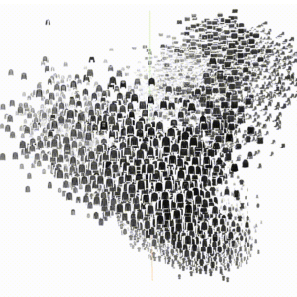](https://github.com/zalandoresearch/fashion-mnist?utm_source=mybridge&utm_medium=blog&utm_campaign=read_more)](https://github.com/zalandoresearch/fashion-mnist?utm_source=mybridge&utm_medium=blog&utm_campaign=read_more)

[**No 16**](https://github.com/facebookresearch/ParlAI?utm_source=mybridge&utm_medium=blog&utm_campaign=read_more)

ParlAI: A framework for training and evaluating AI models on a variety of openly available dialog datasets **[2578 stars on Github]**. Courtesy of Alexander Miller at [Facebook Research](https://medium.com/@FBResearch)

[[](https://github.com/facebookresearch/ParlAI?utm_source=mybridge&utm_medium=blog&utm_campaign=read_more)](https://github.com/facebookresearch/ParlAI?utm_source=mybridge&utm_medium=blog&utm_campaign=read_more)

[**No 17**](https://github.com/facebookresearch/fairseq?utm_source=mybridge&utm_medium=blog&utm_campaign=read_more)

Fairseq: Facebook AI Research Sequence-to-Sequence Toolkit **[2571 stars on Github]**.

[[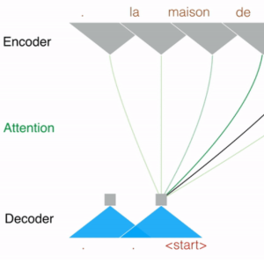](https://github.com/facebookresearch/fairseq?utm_source=mybridge&utm_medium=blog&utm_campaign=read_more)](https://github.com/facebookresearch/fairseq?utm_source=mybridge&utm_medium=blog&utm_campaign=read_more)

[**No 18**](https://github.com/uber/pyro?utm_source=mybridge&utm_medium=blog&utm_campaign=read_more)

Pyro: Deep universal probabilistic programming with Python and PyTorch **[2387 stars on Github]**. Courtesy of Uber AI Labs

[[](https://github.com/uber/pyro?utm_source=mybridge&utm_medium=blog&utm_campaign=read_more)](https://github.com/uber/pyro?utm_source=mybridge&utm_medium=blog&utm_campaign=read_more)

[**No 19**](https://github.com/junyanz/iGAN?utm_source=mybridge&utm_medium=blog&utm_campaign=read_more)

iGAN: Interactive Image Generation powered by GAN **[2369 stars on Github]**.

[[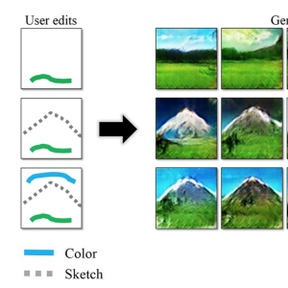](https://github.com/junyanz/iGAN?utm_source=mybridge&utm_medium=blog&utm_campaign=read_more)](https://github.com/junyanz/iGAN?utm_source=mybridge&utm_medium=blog&utm_campaign=read_more)

[**No 20**](https://github.com/DmitryUlyanov/deep-image-prior?utm_source=mybridge&utm_medium=blog&utm_campaign=read_more)

Deep-image-prior: Image restoration with neural networks but without learning **[2188 stars on Github]**. Courtesy of Dmitry Ulyanov, Ph.D at Skoltech

[[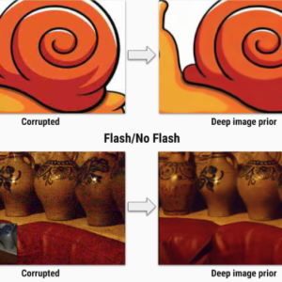](https://github.com/DmitryUlyanov/deep-image-prior?utm_source=mybridge&utm_medium=blog&utm_campaign=read_more)](https://github.com/DmitryUlyanov/deep-image-prior?utm_source=mybridge&utm_medium=blog&utm_campaign=read_more)

[**No 21**](https://github.com/oarriaga/face_classification?utm_source=mybridge&utm_medium=blog&utm_campaign=read_more)

Face\_classification: Real-time face detection and emotion/gender classification using fer2013/imdb datasets with a keras CNN model and openCV. **[1967 stars on Github]**.

[[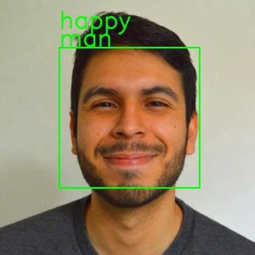](https://github.com/oarriaga/face_classification?utm_source=mybridge&utm_medium=blog&utm_campaign=read_more)](https://github.com/oarriaga/face_classification?utm_source=mybridge&utm_medium=blog&utm_campaign=read_more)

[**No 22**](https://github.com/buriburisuri/speech-to-text-wavenet?utm_source=mybridge&utm_medium=blog&utm_campaign=read_more)

Speech-to-Text-WaveNet : End-to-end sentence level English speech recognition using DeepMind’s WaveNet and tensorflow **[1961 stars on Github]**. Courtesy of Namju Kim at Kakao Brain

[[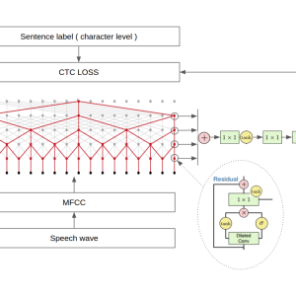](https://github.com/buriburisuri/speech-to-text-wavenet?utm_source=mybridge&utm_medium=blog&utm_campaign=read_more)](https://github.com/buriburisuri/speech-to-text-wavenet?utm_source=mybridge&utm_medium=blog&utm_campaign=read_more)

[**No 23**](https://github.com/yunjey/StarGAN?utm_source=mybridge&utm_medium=blog&utm_campaign=read_more)

StarGAN: Unified Generative Adversarial Networks for Multi-Domain Image-to-Image Translation **[1954 stars on Github]**. Courtesy of [Yunjey Choi](https://medium.com/@yunjey.choi) at Korea University

[[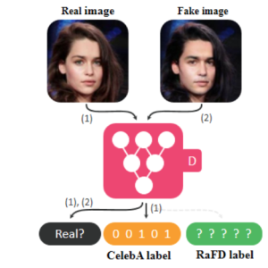](https://github.com/yunjey/StarGAN?utm_source=mybridge&utm_medium=blog&utm_campaign=read_more)](https://github.com/yunjey/StarGAN?utm_source=mybridge&utm_medium=blog&utm_campaign=read_more)

[**No 24**](https://github.com/Unity-Technologies/ml-agents?utm_source=mybridge&utm_medium=blog&utm_campaign=read_more)

Ml-agents: Unity Machine Learning Agents **[1658 stars on Github]**. Courtesy of [Arthur Juliani](https://medium.com/@awjuliani), Deep Learning at Unity3D

[[](https://github.com/Unity-Technologies/ml-agents?utm_source=mybridge&utm_medium=blog&utm_campaign=read_more)](https://github.com/Unity-Technologies/ml-agents?utm_source=mybridge&utm_medium=blog&utm_campaign=read_more)

[**No 25**](https://github.com/AKSHAYUBHAT/DeepVideoAnalytics/?utm_source=mybridge&utm_medium=blog&utm_campaign=read_more)

DeepVideoAnalytics: A distributed visual search and visual data analytics platform **[1494 stars on Github]**. Courtesy of [Akshay Bhat](https://medium.com/@akshayubhat), Ph.D at Cornell University

[[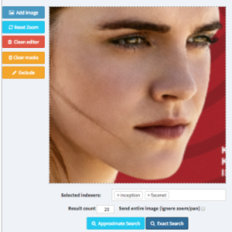](https://github.com/AKSHAYUBHAT/DeepVideoAnalytics/?utm_source=mybridge&utm_medium=blog&utm_campaign=read_more)](https://github.com/AKSHAYUBHAT/DeepVideoAnalytics/?utm_source=mybridge&utm_medium=blog&utm_campaign=read_more)

[**No 26**](https://github.com/OpenNMT/OpenNMT?utm_source=mybridge&utm_medium=blog&utm_campaign=read_more)

OpenNMT: Open-Source Neural Machine Translation in Torch **[1490 stars on Github]**.

[[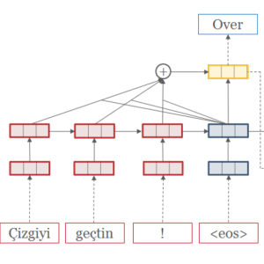](https://github.com/OpenNMT/OpenNMT?utm_source=mybridge&utm_medium=blog&utm_campaign=read_more)](https://github.com/OpenNMT/OpenNMT?utm_source=mybridge&utm_medium=blog&utm_campaign=read_more)

[**No 27**](https://github.com/NVIDIA/pix2pixHD?utm_source=mybridge&utm_medium=blog&utm_campaign=read_more)

Pix2pixHD: Synthesizing and manipulating 2048x1024 images with conditional GANs **[1283 stars on Github]**. Courtesy of [Ming-Yu Liu](https://medium.com/@liu_mingyu) at AI Research Scientist at Nvidia

[[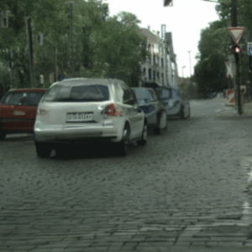](https://github.com/NVIDIA/pix2pixHD?utm_source=mybridge&utm_medium=blog&utm_campaign=read_more)](https://github.com/NVIDIA/pix2pixHD?utm_source=mybridge&utm_medium=blog&utm_campaign=read_more)

[**No 28**](https://github.com/uber/horovod?utm_source=mybridge&utm_medium=blog&utm_campaign=read_more)

Horovod: Distributed training framework for TensorFlow. **[1188 stars on Github]**. Courtesy of Uber Engineering

[[](https://github.com/uber/horovod?utm_source=mybridge&utm_medium=blog&utm_campaign=read_more)](https://github.com/uber/horovod?utm_source=mybridge&utm_medium=blog&utm_campaign=read_more)

[**No 29**](https://github.com/MrNothing/AI-Blocks?utm_source=mybridge&utm_medium=blog&utm_campaign=read_more)

AI-Blocks: A powerful and intuitive WYSIWYG interface that allows anyone to create Machine Learning models **[899 stars on Github]**.

[[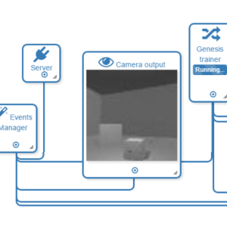](https://github.com/MrNothing/AI-Blocks?utm_source=mybridge&utm_medium=blog&utm_campaign=read_more)](https://github.com/MrNothing/AI-Blocks?utm_source=mybridge&utm_medium=blog&utm_campaign=read_more)

[**No 30**](https://github.com/andabi/deep-voice-conversion?utm_source=mybridge&utm_medium=blog&utm_campaign=read_more)

Deep neural networks for voice conversion (voice style transfer) in Tensorflow **[845 stars on Github]**. Courtesy of [Dabi Ahn](https://medium.com/@dabiahn), AI Research at Kakao Brain

[[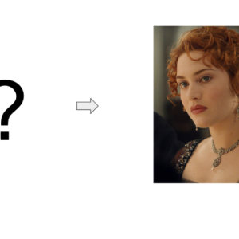](https://github.com/andabi/deep-voice-conversion?utm_source=mybridge&utm_medium=blog&utm_campaign=read_more)](https://github.com/andabi/deep-voice-conversion?utm_source=mybridge&utm_medium=blog&utm_campaign=read_more)

That’s it for Machine Learning open source projects. If you like this curation, read best daily articles based on your programming skills on our [website.](http://mybridge.co/skills/machine-learning)

**January 26, 2018**

# Learn to Build a Machine Learning Application from Top Articles of 2017

For Jan-Dec 2017, we compared nearly 20,000 articles about **creating a machine learning application** and picked the Top 50.

“Hiring a Machine Learning engineer or Data Scientist in Silicon Valley is becoming like hiring a professional athlete. That’s how demanding it is” — [The New York Times](https://goo.gl/DKwC7s)

Data scientists are compared to professional athletes due to high demand by the tech giants

Machine Learning has become one of the most demanding skills in the workforce today, with the average salary in US reaching $134,472 (source: [Indeed](https://goo.gl/7hTLBJ)).

We believe learning from data scientists who have hands-on experience in the field is a great way to advance your career. This directory is designed to make your life easier as it organizes the most useful articles written in 2017, where experienced data scientists share their lessons in building and shipping a machine learning application.

As an article ranking service for professionals, we take “quality” very seriously and make sure each article you read is exceptionally good. This is an extremely competitive directory with only 50 articles selected out of 20,000 (0.25%). [Mybridge AI](https://goo.gl/XKkZ63) is constantly evolving as it ranks articles by the total number of shares & reading time and by our own machine learning algorithm.

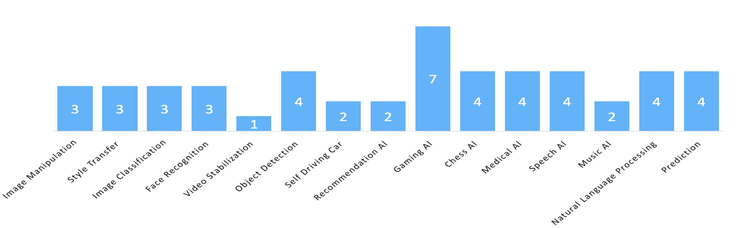This directory has 15 key topics as shown below.

If you’re a beginner who are just getting started, we recommend these courses below,

[A) Gaming AI](http://bit.ly/2nbsc5n)

[[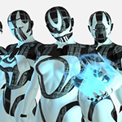](http://bit.ly/2nbsc5n)](http://bit.ly/2nbsc5n)

[The Beginner’s Guide to Building an Artificial Intelligence in Unity.](http://bit.ly/2nbsc5n)

[5,041 recommends, 4.7/5 stars]

[B) Computer Vision](http://bit.ly/2naZ4vg)

[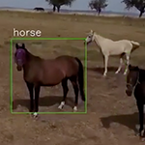](http://bit.ly/2naZ4vg)

[Deep Learning and Computer Vision A-Z™: Learn OpenCV, SSD & GANs and create image recognition apps.](http://bit.ly/2naZ4vg)

[8,161 recommends, 4.5/5 stars]

If you’re looking for open source projects,

* Machine LearningProjects of the Year (avg. 3,558 ⭐️):[Here](https://goo.gl/sqdPgW)



(Click the numbers below. The numbers are **NOT** ordered by ranking in this post)

#### If you like a text version without images: Go to our [Github link](https://goo.gl/DJtDvY)

### <Image Manipulation>

#### [No 1](https://goo.gl/LT78cj)

High-Resolution Image Synthesis and Semantic Manipulation with Conditional GANs. Courtesy of [NVIDIA AI](https://medium.com/@NvidiaAI) and [UC Berkeley](https://medium.com/@UCBerkeley)

[](https://goo.gl/LT78cj)

[**No 2**](https://research.googleblog.com/2017/07/using-deep-learning-to-create.html?utm_source=mybridge&utm_medium=blog&utm_campaign=read_more)

[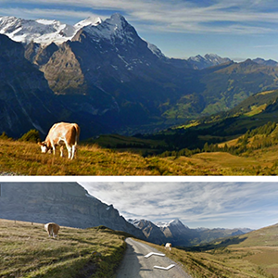](https://research.googleblog.com/2017/07/using-deep-learning-to-create.html?utm_source=mybridge&utm_medium=blog&utm_campaign=read_more)Using Deep Learning to Create Professional-Level Photographs. Courtesy of Hui Fang at Google Research

#### [No 3](https://www.learnopencv.com/high-dynamic-range-hdr-imaging-using-opencv-cpp-python?utm_source=mybridge&utm_medium=blog&utm_campaign=read_more)

[](https://www.learnopencv.com/high-dynamic-range-hdr-imaging-using-opencv-cpp-python?utm_source=mybridge&utm_medium=blog&utm_campaign=read_more)High Dynamic Range (HDR) Imaging using OpenCV (Python). Courtesy of [Satya Mallick](https://medium.com/@LearnOpenCV)



### <Style Transfer>

#### [No 4](https://arxiv.org/abs/1705.01088?utm_source=mybridge&utm_medium=blog&utm_campaign=read_more)

[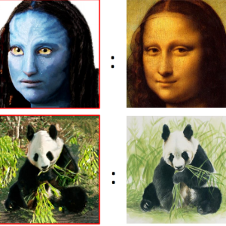](https://arxiv.org/abs/1705.01088?utm_source=mybridge&utm_medium=blog&utm_campaign=read_more)Visual Attribute Transfer through Deep Image Analogy.

#### [No 5](https://arxiv.org/abs/1703.07511?utm_source=mybridge&utm_medium=blog&utm_campaign=read_more)

Deep Photo Style Transfer: A deep-learning approach to photographic style transfer that handles a large variety of image content while faithfully transferring the reference style.

[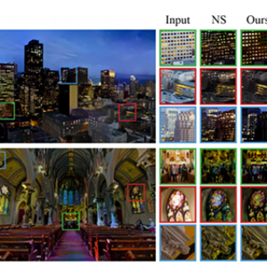](https://arxiv.org/abs/1703.07511?utm_source=mybridge&utm_medium=blog&utm_campaign=read_more)

#### [No 6](https://dmitryulyanov.github.io/deep_image_prior?utm_source=mybridge&utm_medium=blog&utm_campaign=read_more)

Deep Image Prior: Super-resolution, inpainting, denoising without learning on a dataset and pretrained networks. Comparable results to learned methods. Courtesy of [Dmitry Ulyanov](https://medium.com/@dmitry.ulyanov)

[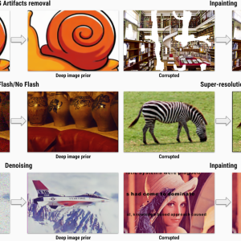](https://dmitryulyanov.github.io/deep_image_prior?utm_source=mybridge&utm_medium=blog&utm_campaign=read_more)



### <Image Classification>

#### [No 7](https://distill.pub/2017/feature-visualization?utm_source=mybridge&utm_medium=blog&utm_campaign=read_more)

Feature Visualization: How neural networks build up their understanding of images. Courtesy of Chris Olah and [Ludwig Schubert](https://medium.com/@ludwigschubert) at Google Brain

[[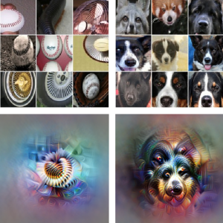](https://distill.pub/2017/feature-visualization?utm_source=mybridge&utm_medium=blog&utm_campaign=read_more)](https://distill.pub/2017/feature-visualization?utm_source=mybridge&utm_medium=blog&utm_campaign=read_more)

#### [No 8](https://github.com/humphd/have-fun-with-machine-learning?utm_source=mybridge&utm_medium=blog&utm_campaign=read_more)

An absolute beginner’s guide to Image Classification with Neural Networks **[4481 stars on Github]**. Courtesy of [David Humphrey](https://medium.com/@humphd) at Mozilla Firefox

[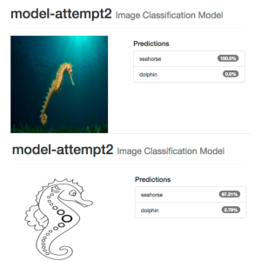](https://github.com/humphd/have-fun-with-machine-learning?utm_source=mybridge&utm_medium=blog&utm_campaign=read_more)

#### [No 9](https://medium.com/towards-data-science/background-removal-with-deep-learning-c4f2104b3157?utm_source=mybridge&utm_medium=blog&utm_campaign=read_more)

Background removal with deep learning. Courtesy of [Gidi Shperber](https://medium.com/@gidishperber)

[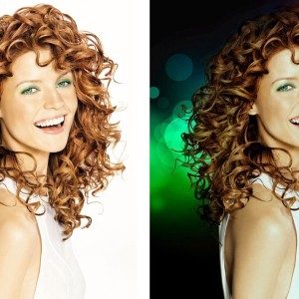](https://medium.com/towards-data-science/background-removal-with-deep-learning-c4f2104b3157?utm_source=mybridge&utm_medium=blog&utm_campaign=read_more)



### <Face Recognition>

#### [No 10](https://goo.gl/bGS3Cd)

Large Pose 3D Face Reconstruction from a Single Image via Direct Volumetric CNN Regression. Courtesy of [Aaron Jackson](https://medium.com/u/16f4e10a21bb)

[[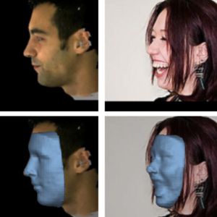](https://goo.gl/bGS3Cd)](https://goo.gl/bGS3Cd)

#### [No 11](http://www.pyimagesearch.com/2017/04/24/eye-blink-detection-opencv-python-dlib?utm_source=mybridge&utm_medium=blog&utm_campaign=read_more)

Eye blink detection with OpenCV, Python, and dlib. Courtesy of Adrian Rosebrock

[[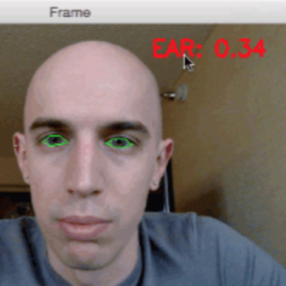](http://www.pyimagesearch.com/2017/04/24/eye-blink-detection-opencv-python-dlib?utm_source=mybridge&utm_medium=blog&utm_campaign=read_more)](http://www.pyimagesearch.com/2017/04/24/eye-blink-detection-opencv-python-dlib?utm_source=mybridge&utm_medium=blog&utm_campaign=read_more)

#### [No 12](https://www.makeartwithpython.com/blog/deal-with-it-generator-face-recognition?utm_source=mybridge&utm_medium=blog&utm_campaign=read_more)

DEAL WITH IT in Python with Face Detection. Courtesy of Kirk Kaiser

[[](https://www.makeartwithpython.com/blog/deal-with-it-generator-face-recognition?utm_source=mybridge&utm_medium=blog&utm_campaign=read_more)](https://www.makeartwithpython.com/blog/deal-with-it-generator-face-recognition?utm_source=mybridge&utm_medium=blog&utm_campaign=read_more)



### <Video Stabilization>

#### [No 13](https://research.googleblog.com/2017/11/fused-video-stabilization-on-pixel-2.html?utm_source=mybridge&utm_medium=blog&utm_campaign=read_more)

Fused Video Stabilization on the Pixel 2 and Pixel 2 XL. [Chia-Kai Liang](https://medium.com/@liangck) at Google Research[](https://research.googleblog.com/2017/11/fused-video-stabilization-on-pixel-2.html?utm_source=mybridge&utm_medium=blog&utm_campaign=read_more)



### <Object Detection>

#### [No 14](https://hackernoon.com/how-hbos-silicon-valley-built-not-hotdog-with-mobile-tensorflow-keras-react-native-ef03260747f3?utm_source=mybridge&utm_medium=blog&utm_campaign=read_more)

How HBO’s Silicon Valley built “Not Hotdog” with mobile TensorFlow and Keras. Coutesy of [Tim Anglade](https://medium.com/@timanglade)

[[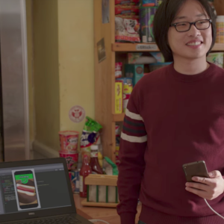](https://hackernoon.com/how-hbos-silicon-valley-built-not-hotdog-with-mobile-tensorflow-keras-react-native-ef03260747f3?utm_source=mybridge&utm_medium=blog&utm_campaign=read_more)](https://hackernoon.com/how-hbos-silicon-valley-built-not-hotdog-with-mobile-tensorflow-keras-react-native-ef03260747f3?utm_source=mybridge&utm_medium=blog&utm_campaign=read_more)

#### [No 15](https://tryolabs.com/blog/2017/08/30/object-detection-an-overview-in-the-age-of-deep-learning?utm_source=mybridge&utm_medium=blog&utm_campaign=read_more)

Object detection: an overview in the age of Deep Learning. Courtesy of [Tryolabs](https://medium.com/@tryolabs)

[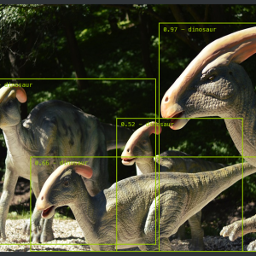](https://tryolabs.com/blog/2017/08/30/object-detection-an-overview-in-the-age-of-deep-learning?utm_source=mybridge&utm_medium=blog&utm_campaign=read_more)

#### [No 16](https://medium.com/towards-data-science/how-to-train-your-own-object-detector-with-tensorflows-object-detector-api-bec72ecfe1d9?utm_source=mybridge&utm_medium=blog&utm_campaign=read_more)

How to train your own Object Detector with TensorFlow’s Object Detector API. Courtesy of [Dat Tran](https://medium.com/@datitran)

[[](https://medium.com/towards-data-science/how-to-train-your-own-object-detector-with-tensorflows-object-detector-api-bec72ecfe1d9?utm_source=mybridge&utm_medium=blog&utm_campaign=read_more)](https://medium.com/towards-data-science/how-to-train-your-own-object-detector-with-tensorflows-object-detector-api-bec72ecfe1d9?utm_source=mybridge&utm_medium=blog&utm_campaign=read_more)

#### [No 17](http://www.pyimagesearch.com/2017/09/18/real-time-object-detection-with-deep-learning-and-opencv?utm_source=mybridge&utm_medium=blog&utm_campaign=read_more)

Real-time object detection with deep learning and OpenCV.

[[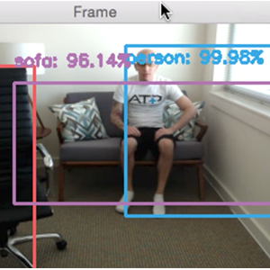](http://www.pyimagesearch.com/2017/09/18/real-time-object-detection-with-deep-learning-and-opencv?utm_source=mybridge&utm_medium=blog&utm_campaign=read_more)](http://www.pyimagesearch.com/2017/09/18/real-time-object-detection-with-deep-learning-and-opencv?utm_source=mybridge&utm_medium=blog&utm_campaign=read_more)



### <Self Driving Car>

#### [No 18](https://www.youtube.com/watch?v=ks4MPfMq8aQ?utm_source=mybridge&utm_medium=blog&utm_campaign=read_more)

Self-driving Grand Theft Auto V with Python : Intro [Part I]. Courtesy of [Sentdex](https://medium.com/@Sentdex)

[[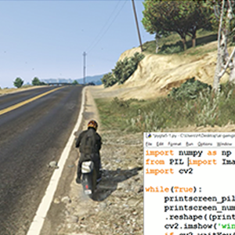](https://www.youtube.com/watch?v=ks4MPfMq8aQ?utm_source=mybridge&utm_medium=blog&utm_campaign=read_more)](https://www.youtube.com/watch?v=ks4MPfMq8aQ?utm_source=mybridge&utm_medium=blog&utm_campaign=read_more)

#### [No 19](https://medium.freecodecamp.com/recognizing-traffic-lights-with-deep-learning-23dae23287cc?utm_source=mybridge&utm_medium=blog&utm_campaign=read_more)

Recognizing Traffic Lights With Deep Learning: How I learned deep learning in 10 weeks and won $5,000. Courtesy of [David Brailovsky](https://medium.com/@davidbrai) and [freeCodeCamp](https://medium.com/@FreeCodeCamp)

[[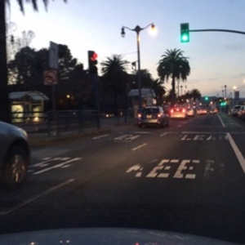](https://medium.freecodecamp.com/recognizing-traffic-lights-with-deep-learning-23dae23287cc?utm_source=mybridge&utm_medium=blog&utm_campaign=read_more)](https://medium.freecodecamp.com/recognizing-traffic-lights-with-deep-learning-23dae23287cc?utm_source=mybridge&utm_medium=blog&utm_campaign=read_more)



### <Recommendation Al>

#### [No 20](https://goo.gl/bSD9wE)

Spotify’s Discover Weekly: How machine learning finds your new music. Courtesy of [Sophia Ciocca](https://medium.com/@sophiaciocca) and [Hackernoon](https://medium.com/@hackernoon)

[[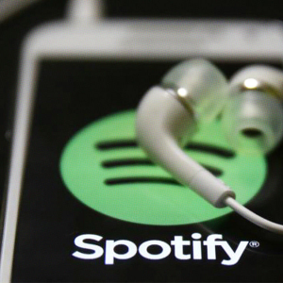](https://goo.gl/bSD9wE)](https://goo.gl/bSD9wE)

#### [No 21](https://medium.com/netflix-techblog/artwork-personalization-c589f074ad76?utm_source=mybridge&utm_medium=blog&utm_campaign=read_more)

Artwork Personalization at Netflix. Courtesy of [Netflix Technology Blog](https://medium.com/@NetflixTechBlog)

[[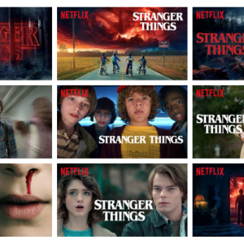](https://medium.com/netflix-techblog/artwork-personalization-c589f074ad76?utm_source=mybridge&utm_medium=blog&utm_campaign=read_more)](https://medium.com/netflix-techblog/artwork-personalization-c589f074ad76?utm_source=mybridge&utm_medium=blog&utm_campaign=read_more)



### <Gaming Al>

#### [No 22](https://www.youtube.com/watch?v=Ipi40cb_RsI?utm_source=mybridge&utm_medium=blog&utm_campaign=read_more)

MariFlow — Self-Driving Mario Kart w/Recurrent Neural Network. Courtesy of SethBling

[[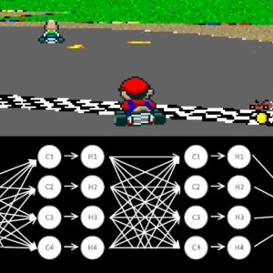](https://www.youtube.com/watch?v=Ipi40cb_RsI?utm_source=mybridge&utm_medium=blog&utm_campaign=read_more)](https://www.youtube.com/watch?v=Ipi40cb_RsI?utm_source=mybridge&utm_medium=blog&utm_campaign=read_more)

#### [No 23](https://blog.openai.com/openai-baselines-dqn?utm_source=mybridge&utm_medium=blog&utm_campaign=read_more)

OpenAI Baselines: DQN. Reproduce reinforcement learning algorithms with performance on par with published results. Courtesy of OpenAI

[[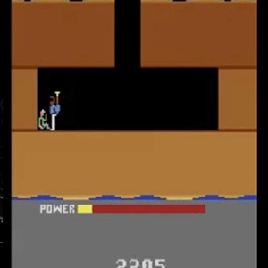](https://blog.openai.com/openai-baselines-dqn?utm_source=mybridge&utm_medium=blog&utm_campaign=read_more)](https://blog.openai.com/openai-baselines-dqn?utm_source=mybridge&utm_medium=blog&utm_campaign=read_more)

#### [No 24](https://blog.openai.com/more-on-dota-2?utm_source=mybridge&utm_medium=blog&utm_campaign=read_more)

Reinforcement Learning on Dota 2 [Part II]. Courtesy of OpenAI

[[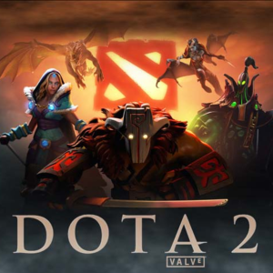](https://blog.openai.com/more-on-dota-2?utm_source=mybridge&utm_medium=blog&utm_campaign=read_more)](https://blog.openai.com/more-on-dota-2?utm_source=mybridge&utm_medium=blog&utm_campaign=read_more)

[No 25](https://www.codelitt.com/blog/doom-ai?utm_source=mybridge&utm_medium=blog&utm_campaign=read_more)

Creating an AI DOOM bot

[[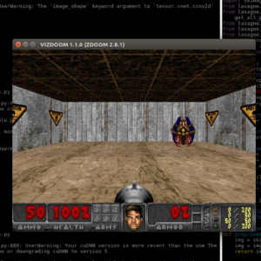](https://www.codelitt.com/blog/doom-ai?utm_source=mybridge&utm_medium=blog&utm_campaign=read_more)](https://www.codelitt.com/blog/doom-ai?utm_source=mybridge&utm_medium=blog&utm_campaign=read_more)

[No 26](http://theorangeduck.com/page/phase-functioned-neural-networks-character-control?utm_source=mybridge&utm_medium=blog&utm_campaign=read_more)

#### Phase-Functioned Neural Networks for Character Control. Courtesy of Daniel Holden`

[[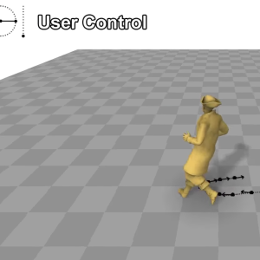](http://theorangeduck.com/page/phase-functioned-neural-networks-character-control?utm_source=mybridge&utm_medium=blog&utm_campaign=read_more)](http://theorangeduck.com/page/phase-functioned-neural-networks-character-control?utm_source=mybridge&utm_medium=blog&utm_campaign=read_more)

[No 27](https://arxiv.org/abs/1702.05663?utm_source=mybridge&utm_medium=blog&utm_campaign=read_more)

The Game Imitation: Deep Supervised Convolutional Networks for Quick Video Game AI. Courtesy of [Stanford University](https://medium.com/@Stanford)

[[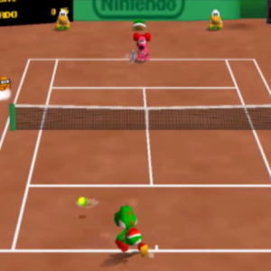](https://arxiv.org/abs/1702.05663?utm_source=mybridge&utm_medium=blog&utm_campaign=read_more)](https://arxiv.org/abs/1702.05663?utm_source=mybridge&utm_medium=blog&utm_campaign=read_more)

#### [No 28](https://blogs.unity3d.com/2017/09/19/introducing-unity-machine-learning-agents?utm_source=mybridge&utm_medium=blog&utm_campaign=read_more)

Introducing: Unity Machine Learning Agents. Courtesy of [Arthur Juliani](https://medium.com/@awjuliani) at Unity

[[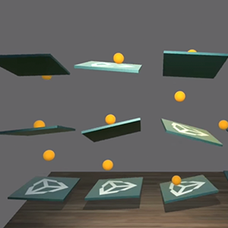](https://blogs.unity3d.com/2017/09/19/introducing-unity-machine-learning-agents?utm_source=mybridge&utm_medium=blog&utm_campaign=read_more)](https://blogs.unity3d.com/2017/09/19/introducing-unity-machine-learning-agents?utm_source=mybridge&utm_medium=blog&utm_campaign=read_more)



### <Chess Al>

### [No 29](https://arxiv.org/abs/1712.01815?utm_source=mybridge&utm_medium=blog&utm_campaign=read_more)

Mastering Chess and Shogi by Self-Play with a General Reinforcement Learning Algorithm. Courtesy of Deepmind

[[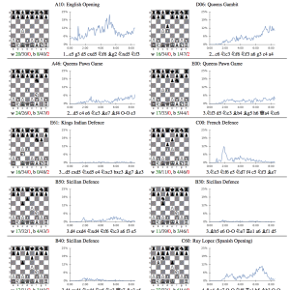](https://arxiv.org/abs/1712.01815?utm_source=mybridge&utm_medium=blog&utm_campaign=read_more)](https://arxiv.org/abs/1712.01815?utm_source=mybridge&utm_medium=blog&utm_campaign=read_more)

#### [No 30](https://goo.gl/nfKUMo)

#### AlphaGo Zero: Learning from scratch. Courtesy of DeepMind.

[[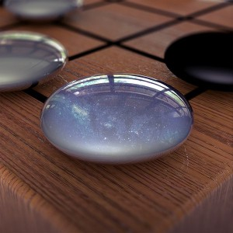](https://goo.gl/nfKUMo)](https://goo.gl/nfKUMo)

#### [No 31](https://www.youtube.com/watch?v=vC66XFoN4DE?utm_source=mybridge&utm_medium=blog&utm_campaign=read_more)

How Does DeepMind’s AlphaGo Zero Work? Courtesy of [Siraj Raval](https://medium.com/@siraj_raval)

[[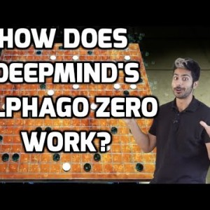](https://www.youtube.com/watch?v=vC66XFoN4DE?utm_source=mybridge&utm_medium=blog&utm_campaign=read_more)](https://www.youtube.com/watch?v=vC66XFoN4DE?utm_source=mybridge&utm_medium=blog&utm_campaign=read_more)

#### [No 32](https://medium.freecodecamp.com/simple-chess-ai-step-by-step-1d55a9266977?utm_source=mybridge&utm_medium=blog&utm_campaign=read_more)

A step-by-step guide to building a simple chess AI. Courtesy of [Lauri Hartikka](https://medium.com/@lhartikk)

[[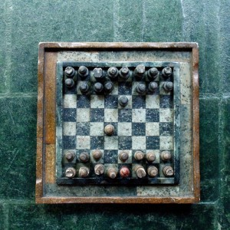](https://medium.freecodecamp.com/simple-chess-ai-step-by-step-1d55a9266977?utm_source=mybridge&utm_medium=blog&utm_campaign=read_more)](https://medium.freecodecamp.com/simple-chess-ai-step-by-step-1d55a9266977?utm_source=mybridge&utm_medium=blog&utm_campaign=read_more)



### <Medical Al>

#### [No 33](https://stanfordmlgroup.github.io/projects/chexnet?utm_source=mybridge&utm_medium=blog&utm_campaign=read_more)

CheXNet: Radiologist-Level Pneumonia Detection on Chest X-Rays with Deep Learning. Courtesy of [Andrew Ng](https://medium.com/@andrewng) and others at Stanford ML Group

[[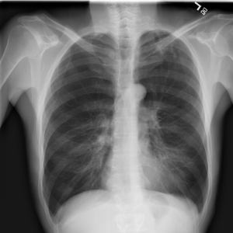](https://stanfordmlgroup.github.io/projects/chexnet?utm_source=mybridge&utm_medium=blog&utm_campaign=read_more)](https://stanfordmlgroup.github.io/projects/chexnet?utm_source=mybridge&utm_medium=blog&utm_campaign=read_more)

#### [No 34](http://juliandewit.github.io/kaggle-ndsb2017?utm_source=mybridge&utm_medium=blog&utm_campaign=read_more)

Can you improve lung cancer detection? 2nd place solution for the Data Science Bowl 2017.

[[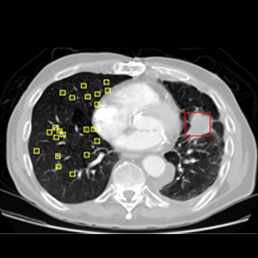](http://juliandewit.github.io/kaggle-ndsb2017?utm_source=mybridge&utm_medium=blog&utm_campaign=read_more)](http://juliandewit.github.io/kaggle-ndsb2017?utm_source=mybridge&utm_medium=blog&utm_campaign=read_more)

#### [No 35](https://stanfordmlgroup.github.io/projects/improving-palliative-care?utm_source=mybridge&utm_medium=blog&utm_campaign=read_more)

Improving Palliative Care with Deep Learning. Courtesy of [Andrew Ng](https://medium.com/@andrewng) and others at Stanford ML Group

[[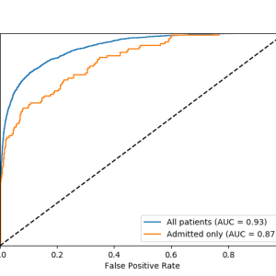](https://stanfordmlgroup.github.io/projects/improving-palliative-care?utm_source=mybridge&utm_medium=blog&utm_campaign=read_more)](https://stanfordmlgroup.github.io/projects/improving-palliative-care?utm_source=mybridge&utm_medium=blog&utm_campaign=read_more)

#### [No 36](https://blog.insightdatascience.com/heart-disease-diagnosis-with-deep-learning-c2d92c27e730?utm_source=mybridge&utm_medium=blog&utm_campaign=read_more)

Heart Disease Diagnosis with Deep Learning. Courtesy of [Chuck-Hou Yee](https://medium.com/@chuckyee)

[[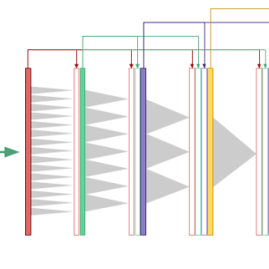](https://blog.insightdatascience.com/heart-disease-diagnosis-with-deep-learning-c2d92c27e730?utm_source=mybridge&utm_medium=blog&utm_campaign=read_more)](https://blog.insightdatascience.com/heart-disease-diagnosis-with-deep-learning-c2d92c27e730?utm_source=mybridge&utm_medium=blog&utm_campaign=read_more)



### <Speech Al>

### [No 37](https://arxiv.org/abs/1703.10135?utm_source=mybridge&utm_medium=blog&utm_campaign=read_more)

Tacotron: A Fully End-to-End Text-To-Speech Synthesis Model — Data Scientists at Google.

[[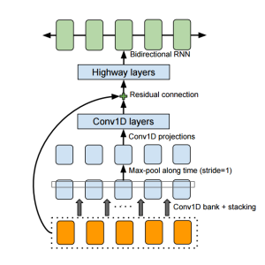](https://arxiv.org/abs/1703.10135?utm_source=mybridge&utm_medium=blog&utm_campaign=read_more)](https://arxiv.org/abs/1703.10135?utm_source=mybridge&utm_medium=blog&utm_campaign=read_more)

#### [No 38](https://distill.pub/2017/ctc/?utm_source=mybridge&utm_medium=blog&utm_campaign=read_more)

Sequence Modeling with CTC. Courtesy of Awni Hannun, Ph.D at Stanford

[[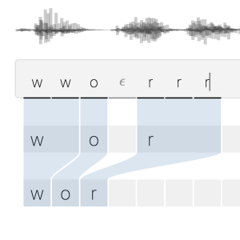](https://distill.pub/2017/ctc/?utm_source=mybridge&utm_medium=blog&utm_campaign=read_more)](https://distill.pub/2017/ctc/?utm_source=mybridge&utm_medium=blog&utm_campaign=read_more)

#### [No 39](https://arxiv.org/abs/1702.07825?utm_source=mybridge&utm_medium=blog&utm_campaign=read_more)

Deep Voice: Real-time Neural Text-to-Speech — Baidu Silicon Valley AI Lab.

[[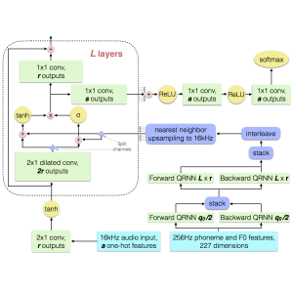](https://arxiv.org/abs/1702.07825?utm_source=mybridge&utm_medium=blog&utm_campaign=read_more)](https://arxiv.org/abs/1702.07825?utm_source=mybridge&utm_medium=blog&utm_campaign=read_more)

#### [No 40](https://goo.gl/8iDha4)

Deep Learning for Siri’s Voice: On-device Deep Mixture Density Networks for Hybrid Unit Selection Synthesis — Apple.

[[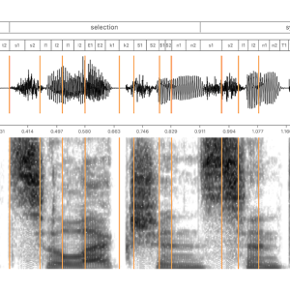](https://goo.gl/8iDha4)](https://goo.gl/8iDha4)



### <Music Al>

#### [No 41](https://www.youtube.com/watch?v=SacogDL_4JU?utm_source=mybridge&utm_medium=blog&utm_campaign=read_more)

Computer evolves to generate baroque music! Courtesy of Cary Huang

[[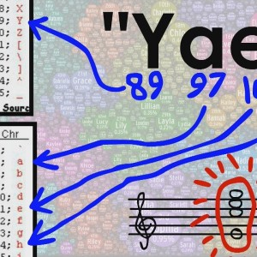](https://www.youtube.com/watch?v=SacogDL_4JU?utm_source=mybridge&utm_medium=blog&utm_campaign=read_more)](https://www.youtube.com/watch?v=SacogDL_4JU?utm_source=mybridge&utm_medium=blog&utm_campaign=read_more)

#### [No 42](https://magenta.tensorflow.org/nsynth-instrument?utm_source=mybridge&utm_medium=blog&utm_campaign=read_more)

Make your own music with WaveNets: Making a Neural Synthesizer Instrument. Courtesy of [Jesse Engelberg](https://medium.com/@jaengelberg)

[[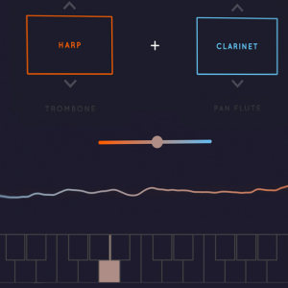](https://magenta.tensorflow.org/nsynth-instrument?utm_source=mybridge&utm_medium=blog&utm_campaign=read_more)](https://magenta.tensorflow.org/nsynth-instrument?utm_source=mybridge&utm_medium=blog&utm_campaign=read_more)



### <Natural Language Processing>

#### [No 43](https://openai.com/blog/learning-to-communicate?utm_source=mybridge&utm_medium=blog&utm_campaign=read_more)

Learning to communicate: Agents developing their own language — OpenAI Research.

[[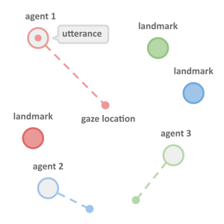](https://openai.com/blog/learning-to-communicate?utm_source=mybridge&utm_medium=blog&utm_campaign=read_more)](https://openai.com/blog/learning-to-communicate?utm_source=mybridge&utm_medium=blog&utm_campaign=read_more)

#### [No 44](https://medium.freecodecamp.com/big-picture-machine-learning-classifying-text-with-neural-networks-and-tensorflow-d94036ac2274?utm_source=mybridge&utm_medium=blog&utm_campaign=read_more)

Big Picture Machine Learning: Classifying Text with Neural Networks and TensorFlow. Courtesy of [Déborah Mesquita](https://medium.com/@dehhmesquita)

[[](https://medium.freecodecamp.com/big-picture-machine-learning-classifying-text-with-neural-networks-and-tensorflow-d94036ac2274?utm_source=mybridge&utm_medium=blog&utm_campaign=read_more)](https://medium.freecodecamp.com/big-picture-machine-learning-classifying-text-with-neural-networks-and-tensorflow-d94036ac2274?utm_source=mybridge&utm_medium=blog&utm_campaign=read_more)

#### [No 45](https://code.facebook.com/posts/1978007565818999/a-novel-approach-to-neural-machine-translation?utm_source=mybridge&utm_medium=blog&utm_campaign=read_more)

A novel approach to neural machine translation — Facebook AI Research.

[[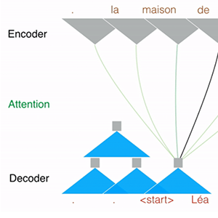](https://code.facebook.com/posts/1978007565818999/a-novel-approach-to-neural-machine-translation?utm_source=mybridge&utm_medium=blog&utm_campaign=read_more)](https://code.facebook.com/posts/1978007565818999/a-novel-approach-to-neural-machine-translation?utm_source=mybridge&utm_medium=blog&utm_campaign=read_more)

#### [No 46](https://blog.conceptnet.io/2017/07/13/how-to-make-a-racist-ai-without-really-trying?utm_source=mybridge&utm_medium=blog&utm_campaign=read_more)

How to make a racist AI without really trying.

[[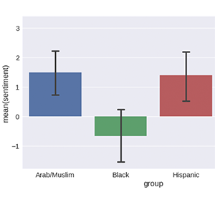](https://blog.conceptnet.io/2017/07/13/how-to-make-a-racist-ai-without-really-trying?utm_source=mybridge&utm_medium=blog&utm_campaign=read_more)](https://blog.conceptnet.io/2017/07/13/how-to-make-a-racist-ai-without-really-trying?utm_source=mybridge&utm_medium=blog&utm_campaign=read_more)



### <Prediction>

#### [No 47](https://medium.com/airbnb-engineering/using-machine-learning-to-predict-value-of-homes-on-airbnb-9272d3d4739d?utm_source=mybridge&utm_medium=blog&utm_campaign=read_more)

Using Machine Learning to Predict Value of Homes On Airbnb. Courtesy of [Robert Chang](https://medium.com/@rchang), Data at Aribnb

[[](https://medium.com/airbnb-engineering/using-machine-learning-to-predict-value-of-homes-on-airbnb-9272d3d4739d?utm_source=mybridge&utm_medium=blog&utm_campaign=read_more)](https://medium.com/airbnb-engineering/using-machine-learning-to-predict-value-of-homes-on-airbnb-9272d3d4739d?utm_source=mybridge&utm_medium=blog&utm_campaign=read_more)

#### [No 48](https://eng.uber.com/neural-networks-uncertainty-estimation?utm_source=mybridge&utm_medium=blog&utm_campaign=read_more)

#### Engineering Uncertainty Estimation in Neural Networks for Time Series Prediction at Uber.

[[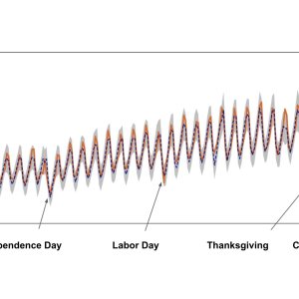](https://eng.uber.com/neural-networks-uncertainty-estimation?utm_source=mybridge&utm_medium=blog&utm_campaign=read_more)](https://eng.uber.com/neural-networks-uncertainty-estimation?utm_source=mybridge&utm_medium=blog&utm_campaign=read_more)

#### [No 49](https://research.googleblog.com/2017/02/using-machine-learning-to-predict.html?utm_source=mybridge&utm_medium=blog&utm_campaign=read_more)

Using Machine Learning to make parking easier.

[[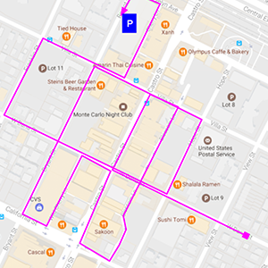](https://research.googleblog.com/2017/02/using-machine-learning-to-predict.html?utm_source=mybridge&utm_medium=blog&utm_campaign=read_more)](https://research.googleblog.com/2017/02/using-machine-learning-to-predict.html?utm_source=mybridge&utm_medium=blog&utm_campaign=read_more)

#### [No 50](https://goo.gl/QpvfsX)

#### How to Predict Stock Prices Easily — Intro to Deep Learning #7.

#### [[https://cdn-images-1.medium.com/max/800/0*szPXlfJDPZHRjvpi.jpg](https://goo.gl/QpvfsX)](https://goo.gl/QpvfsX)

[](https://goo.gl/QpvfsX)

#### If you like a text version without images: Go to our [Github link](https://goo.gl/DJtDvY)

That’s it for Machine Learning Articles of the Year. If you like this curation, read best daily articles based on your programming skills on our [website.](https://goo.gl/suaYCx)

**February 18, 2018**

# Machine Learning Top 10 Open Source Projects (v.Feb 2018)

## This is a new monthly series

For the past month**,** we ranked nearly 250 Machine Learning Open Source Projects to pick the Top 10.

We compared projects with new or major release during this period. [Mybridge AI](https://www.mybridge.co) ranks projects based on a variety of factors to measure its quality for professionals.

* Average number of Github stars in this edition: **2,540** ⭐️
* “Watch” Machine Learning Top 10 Open Source on [**Github**](https://goo.gl/AwJT6Q) and get email once a month.
* Topics: Object Detection, Swap Faces, Neural Nets, Predictions, DeepMind, Agent-based AI, Music Generation, Neuroevolution, Translation

Open source projects can be useful for programmers. Hope you find an interesting project that inspires you.



**Course of the month:**

[A) Beginner](http://bit.ly/2Ht3sOr)

[[](http://bit.ly/2Ht3sOr)](http://bit.ly/2Ht3sOr)

[Learn Machine Learning and TensorFlow in Python with Real-Life Business Cases.](http://bit.ly/2Ht3sOr)

**[2,128 recommends, 4.8/5 stars]**



### [Rank 1](https://github.com/facebookresearch/Detectron?utm_source=mybridge&utm_medium=blog&utm_campaign=read_more)

Detectron: FAIR’s research platform for object detection research, implementing popular algorithms like Mask R-CNN and RetinaNet. **[11109 stars on Github]**. Courtesy of [Facebook Research](https://medium.com/@FBResearch)

[[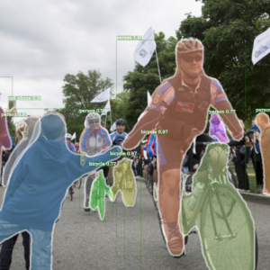](https://github.com/facebookresearch/Detectron?utm_source=mybridge&utm_medium=blog&utm_campaign=read_more)](https://github.com/facebookresearch/Detectron?utm_source=mybridge&utm_medium=blog&utm_campaign=read_more)

### [Rank 2](https://github.com/deepfakes/faceswap?utm_source=mybridge&utm_medium=blog&utm_campaign=read_more)

FaceSwap: A tool that utilizes deep learning to recognize and swap faces in pictures and videos. **[3567 stars on Github]**. Courtesy of [Hidde Jansen](https://medium.com/@ganonmaster)

[[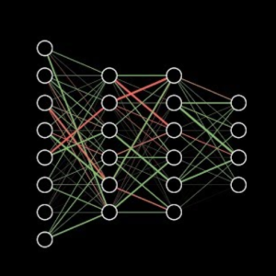](https://github.com/deepfakes/faceswap?utm_source=mybridge&utm_medium=blog&utm_campaign=read_more)](https://github.com/deepfakes/faceswap?utm_source=mybridge&utm_medium=blog&utm_campaign=read_more)

### [Rank 3](https://github.com/openai/gradient-checkpointing?utm_source=mybridge&utm_medium=blog&utm_campaign=read_more)

Gradient-checkpointing: Make huge neural nets fit in memory **[1073 stars on Github]**. Courtesy of OpenAI

[[](https://github.com/openai/gradient-checkpointing?utm_source=mybridge&utm_medium=blog&utm_campaign=read_more)](https://github.com/openai/gradient-checkpointing?utm_source=mybridge&utm_medium=blog&utm_campaign=read_more)

### [Rank 4](https://github.com/marcotcr/lime?utm_source=mybridge&utm_medium=blog&utm_campaign=read_more)

Lime: Explaining the predictions of any machine learning classifier **[3104 stars on Github]**. Courtesy of Marco Ribeiro

[[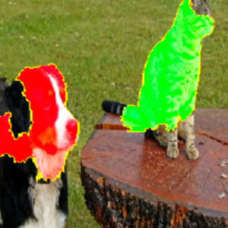](https://github.com/marcotcr/lime?utm_source=mybridge&utm_medium=blog&utm_campaign=read_more)](https://github.com/marcotcr/lime?utm_source=mybridge&utm_medium=blog&utm_campaign=read_more)

### [Rank 5](https://github.com/deepmind/dm_control?utm_source=mybridge&utm_medium=blog&utm_campaign=read_more)

Dm\_control: The DeepMind Control Suite and Control Package **[873 stars on Github]**. Courtesy of DeepMind

[[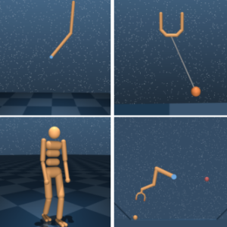](https://github.com/deepmind/dm_control?utm_source=mybridge&utm_medium=blog&utm_campaign=read_more)](https://github.com/deepmind/dm_control?utm_source=mybridge&utm_medium=blog&utm_campaign=read_more)

### [Rank 6](https://github.com/deepmind/lab/tree/master/game_scripts/levels/contributed/psychlab?utm_source=mybridge&utm_medium=blog&utm_campaign=read_more)

Psychlab: Experimental paradigms implemented using the Psychlab platform (3D platform for agent-based AI) **[4763 stars on Github]**. Courtesy of [Charles Beattie](https://medium.com/@charlesbeattie) and Deepmind

[[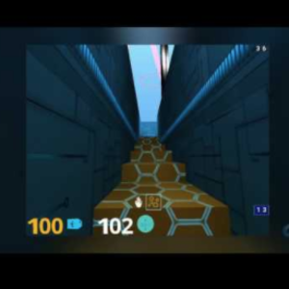](https://github.com/deepmind/lab/tree/master/game_scripts/levels/contributed/psychlab?utm_source=mybridge&utm_medium=blog&utm_campaign=read_more)](https://github.com/deepmind/lab/tree/master/game_scripts/levels/contributed/psychlab?utm_source=mybridge&utm_medium=blog&utm_campaign=read_more)

### [Rank 7](https://github.com/calclavia/DeepJ?utm_source=mybridge&utm_medium=blog&utm_campaign=read_more)

Deepj: a deep learning model for style-specific music generation. **[291 stars on Github]**.

[[](https://github.com/calclavia/DeepJ?utm_source=mybridge&utm_medium=blog&utm_campaign=read_more)](https://github.com/calclavia/DeepJ?utm_source=mybridge&utm_medium=blog&utm_campaign=read_more)

### [Rank 8](https://github.com/chrisstroemel/Simple?utm_source=mybridge&utm_medium=blog&utm_campaign=read_more)

Simple: Experimental Global Optimization Algorithm **[201 stars on Github]**. Courtesy of Chrisstroemel

[[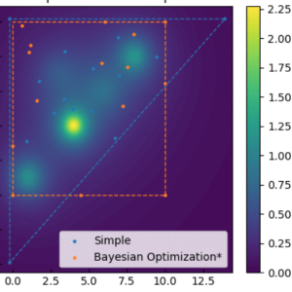](https://github.com/chrisstroemel/Simple?utm_source=mybridge&utm_medium=blog&utm_campaign=read_more)](https://github.com/chrisstroemel/Simple?utm_source=mybridge&utm_medium=blog&utm_campaign=read_more)

### [Rank 9](https://github.com/uber-common/deep-neuroevolution)

Deep-neuroevolution: Deep Neuroevolution. Courtesy of [Uber](https://medium.com/@Uber)

[[](https://github.com/uber-common/deep-neuroevolution)](https://github.com/uber-common/deep-neuroevolution)

### [Rank 10](https://github.com/posenhuang/NPMT?utm_source=mybridge&utm_medium=blog&utm_campaign=read_more)

NPMT: Towards Neural Phrase-based Machine Translation **[50 stars on Github]**. Courtesy of Posenhuang

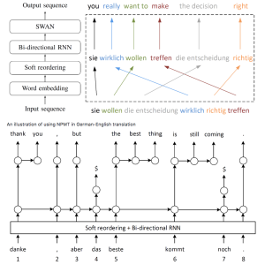

**March 19, 2018**

# Machine Learning Top 10 Open Source Projects (v.Mar 2018)

For the past month**,** we ranked nearly 250 Machine Learning Open Source Projects to pick the Top 10.

We compared projects with new or major release during this period. [Mybridge AI](https://www.mybridge.co) ranks projects based on a variety of factors to measure its quality for professionals.

* Average number of Github stars in this edition: **898**⭐️
* “Watch” Machine Learning Top 10 Open Source on [**Github**](https://goo.gl/AwJT6Q) and get email once a month.
* Topics: Openpose, Domain specific language, Shap, NumPy, Image, Obfuscated Gradients, Physics, PyTorch, TensorFlow, PirateAI

Open source projects can be useful for programmers. Hope you find an interesting project that inspires you.



**Course of the month:**

[**A) Beginners:** Machine Learning A-Z™: Hands-On Python & R In Data Science](http://bit.ly/2oAaMA3). [34,991 recommends, 4.5/5 stars]

B[**) Beginners:** Data Science, Deep Learning, & Machine Learning with Python.](http://bit.ly/2FbgIcv) [7,610 recommends, 4.5/5 stars]



### [Rank 1](https://github.com/CMU-Perceptual-Computing-Lab/openpose?utm_source=mybridge&utm_medium=blog&utm_campaign=read_more)

Openpose: OpenPose: Real-time multi-person keypoint detection library for body, face, and hands estimation **[6199 stars on Github]**.

[[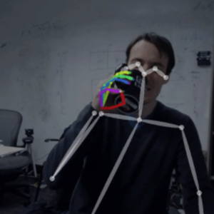](https://github.com/CMU-Perceptual-Computing-Lab/openpose?utm_source=mybridge&utm_medium=blog&utm_campaign=read_more)](https://github.com/CMU-Perceptual-Computing-Lab/openpose?utm_source=mybridge&utm_medium=blog&utm_campaign=read_more)

### [Rank 2](https://github.com/facebookresearch/TensorComprehensions?utm_source=mybridge&utm_medium=blog&utm_campaign=read_more)

TensorComprehensions: A domain specific language to express machine learning workloads. **[937 stars on Github]**. Courtesy of [Facebook Research](https://medium.com/@FBResearch)

[[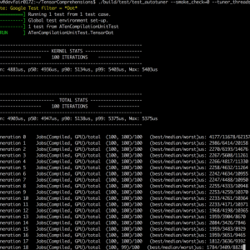](https://github.com/facebookresearch/TensorComprehensions?utm_source=mybridge&utm_medium=blog&utm_campaign=read_more)](https://github.com/facebookresearch/TensorComprehensions?utm_source=mybridge&utm_medium=blog&utm_campaign=read_more)

### [Rank 3](https://github.com/slundberg/shap?utm_source=mybridge&utm_medium=blog&utm_campaign=read_more)

Shap: Explain the output of any machine learning model using expectations and Shapley values. **[821 stars on Github]**. Courtesy of Scott Lundberg

[[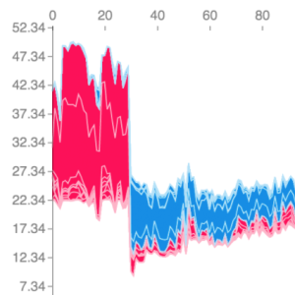](https://github.com/slundberg/shap?utm_source=mybridge&utm_medium=blog&utm_campaign=read_more)](https://github.com/slundberg/shap?utm_source=mybridge&utm_medium=blog&utm_campaign=read_more)

### [Rank 4](https://github.com/eriklindernoren/NapkinML?utm_source=mybridge&utm_medium=blog&utm_campaign=read_more)

NapkinML: A tiny lib with pocket-sized implementations of machine learning models in NumPy. **[320 stars on Github]**. Courtesy of Erik Linder-Norén

[[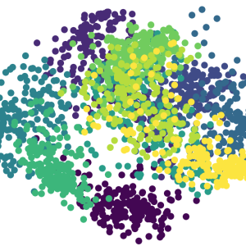](https://github.com/eriklindernoren/NapkinML?utm_source=mybridge&utm_medium=blog&utm_campaign=read_more)](https://github.com/eriklindernoren/NapkinML?utm_source=mybridge&utm_medium=blog&utm_campaign=read_more)

### [Rank 5](https://github.com/shinseung428/GlobalLocalImageCompletion_TF?utm_source=mybridge&utm_medium=blog&utm_campaign=read_more)

GlobalLocalImageCompletion\_TF: Globally and Locally Consistent Image Completion **[51 stars on Github]**. Courtesy of Tony Shin

[[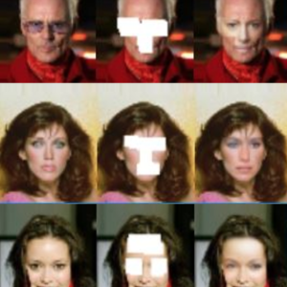](https://github.com/shinseung428/GlobalLocalImageCompletion_TF?utm_source=mybridge&utm_medium=blog&utm_campaign=read_more)](https://github.com/shinseung428/GlobalLocalImageCompletion_TF?utm_source=mybridge&utm_medium=blog&utm_campaign=read_more)

### [Rank 6](https://github.com/anishathalye/obfuscated-gradients?utm_source=mybridge&utm_medium=blog&utm_campaign=read_more)

Obfuscated-gradients: Obfuscated Gradients Give a False Sense of Security: Circumventing Defenses to Adversarial Examples **[277 stars on Github]**. Courtesy of [Anish Athalye](https://medium.com/@anishathalye)

[[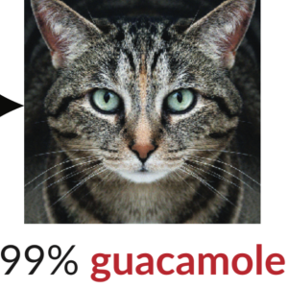](https://github.com/anishathalye/obfuscated-gradients?utm_source=mybridge&utm_medium=blog&utm_campaign=read_more)](https://github.com/anishathalye/obfuscated-gradients?utm_source=mybridge&utm_medium=blog&utm_campaign=read_more)

### [Rank 7](https://github.com/Mrgemy95/visual-interaction-networks-pytorch?utm_source=mybridge&utm_medium=blog&utm_campaign=read_more)

Visual-interaction-networks-pytorch: This’s an implementation of deepmind Visual Interaction Networks paper using pytorch **[112 stars on Github]**. Courtesy of [Mahmoud Gamal](https://medium.com/@mahmoud.gemy18)

[[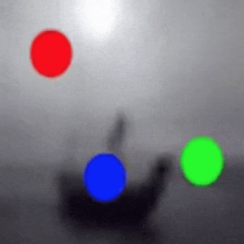](https://github.com/Mrgemy95/visual-interaction-networks-pytorch?utm_source=mybridge&utm_medium=blog&utm_campaign=read_more)](https://github.com/Mrgemy95/visual-interaction-networks-pytorch?utm_source=mybridge&utm_medium=blog&utm_campaign=read_more)

### [Rank 8](https://github.com/orobix/Prototypical-Networks-for-Few-shot-Learning-PyTorch?utm_source=mybridge&utm_medium=blog&utm_campaign=read_more)

Prototypical-Networks-for-Few-shot-Learning-PyTorch: Implementation of Prototypical Networks for Few Shot Learning (https://arxiv.org/abs/1703.05175) in Pytorch **[115 stars on Github]**. Courtesy of Orobix

[[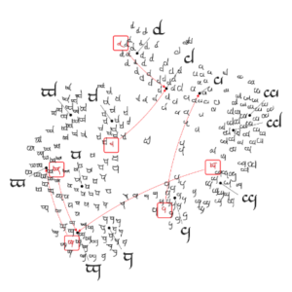](https://github.com/orobix/Prototypical-Networks-for-Few-shot-Learning-PyTorch?utm_source=mybridge&utm_medium=blog&utm_campaign=read_more)](https://github.com/orobix/Prototypical-Networks-for-Few-shot-Learning-PyTorch?utm_source=mybridge&utm_medium=blog&utm_campaign=read_more)

### [Rank 9](https://github.com/for-ai/CipherGAN?utm_source=mybridge&utm_medium=blog&utm_campaign=read_more)

TensorFlow implementation of CipherGAN **[55 stars on Github]**. Courtesy of FOR.ai

[[](https://github.com/for-ai/CipherGAN?utm_source=mybridge&utm_medium=blog&utm_campaign=read_more)](https://github.com/for-ai/CipherGAN?utm_source=mybridge&utm_medium=blog&utm_campaign=read_more)

### [Rank 10](https://github.com/HugoCMU/pirateAI?utm_source=mybridge&utm_medium=blog&utm_campaign=read_more)

PirateAI: Pirate trainer (Deep Learning, Autonomous Agents, 3D, Unity, Hyperopt, Keras) **[17 stars on Github]**. Courtesy of Hugo

[[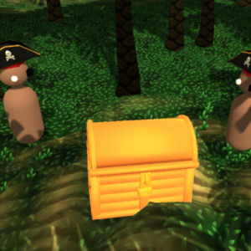](https://github.com/HugoCMU/pirateAI?utm_source=mybridge&utm_medium=blog&utm_campaign=read_more)](https://github.com/HugoCMU/pirateAI?utm_source=mybridge&utm_medium=blog&utm_campaign=read_more)

That’s it for Machine Learning Monthly Open Source. If you like this curation, read best daily articles based on your programming skills on our [website.](http://mybridge.co/skills/machine-learning)

**April 25, 2018**

# Machine Learning Open Source of the Month (v.Apr 2018)

For the past month**,** we ranked nearly 250 Machine Learning Open Source Projects to pick the Top 10.

We compared projects with new or major release during this period. [Mybridge AI](https://www.mybridge.co) ranks projects based on a variety of factors to measure its quality for professionals.

* Average number of Github stars in this edition: **1,385**⭐️
* “Watch” Machine Learning Top 10 Open Source on [**Github**](https://goo.gl/AwJT6Q) and get email once a month.
* Topics: Tensorflow, Augmentation, AlphaGo Zero, NSynth, Deep Neuroevolution, Person Blocker, TCN, Ann Visualizer, Watson

Open source projects can be useful for programmers. Hope you find an interesting project that inspires you.



**Course of the month:**

[**A) Beginners:** Python for Data Science and Machine Learning Bootcamp.](http://bit.ly/2Eso3R0)[18,618 recommends, 4.6/5 stars]

[B**) Artificial Intelligence:** Reinforcement Learning in Python.](http://bit.ly/2GSjWPJ) [1,440 recommends, 4.6/5 stars]



### [Rank 1](https://github.com/tensorflow/tfjs?utm_source=mybridge&utm_medium=blog&utm_campaign=read_more)

Tfjs: A WebGL accelerated, browser based JavaScript library for training and deploying ML models. **[6129 stars on Github]**. Courtesy of [TensorFlow](https://medium.com/@tensorflow)

[[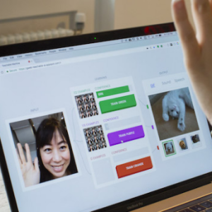](https://github.com/tensorflow/tfjs?utm_source=mybridge&utm_medium=blog&utm_campaign=read_more)](https://github.com/tensorflow/tfjs?utm_source=mybridge&utm_medium=blog&utm_campaign=read_more)

[……[Main Page]](https://js.tensorflow.org/)

### [Rank 2](https://github.com/mdbloice/Augmentor?utm_source=mybridge&utm_medium=blog&utm_campaign=read_more)

Augmentor v0.2: Image augmentation library in Python for machine learning. **[1661 stars on Github]**. Courtesy of Marcus D. Bloice

[[](https://github.com/mdbloice/Augmentor?utm_source=mybridge&utm_medium=blog&utm_campaign=read_more)](https://github.com/mdbloice/Augmentor?utm_source=mybridge&utm_medium=blog&utm_campaign=read_more)

### [Rank 3](https://github.com/tensorflow/hub?utm_source=mybridge&utm_medium=blog&utm_campaign=read_more)

Hub: A library for transfer learning by reusing parts of TensorFlow models. **[350 stars on Github]**. Courtesy of [TensorFlow](https://medium.com/@tensorflow)

[[](https://github.com/tensorflow/hub?utm_source=mybridge&utm_medium=blog&utm_campaign=read_more)](https://github.com/tensorflow/hub?utm_source=mybridge&utm_medium=blog&utm_campaign=read_more)

[……[Introducing TensorFlow Hub]](https://medium.com/tensorflow/introducing-tensorflow-hub-a-library-for-reusable-machine-learning-modules-in-tensorflow-cdee41fa18f9)

### [Rank 4](https://github.com/Zeta36/chess-alpha-zero?utm_source=mybridge&utm_medium=blog&utm_campaign=read_more)

Chess-alpha-zero: Chess reinforcement learning by AlphaGo Zero methods. **[1014 stars on Github]**. Courtesy of Samuel

[[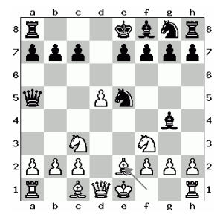](https://github.com/Zeta36/chess-alpha-zero?utm_source=mybridge&utm_medium=blog&utm_campaign=read_more)](https://github.com/Zeta36/chess-alpha-zero?utm_source=mybridge&utm_medium=blog&utm_campaign=read_more)

### [Rank 5](https://github.com/googlecreativelab/open-nsynth-super?utm_source=mybridge&utm_medium=blog&utm_campaign=read_more)

Open-nsynth-super: Open NSynth Super is an experimental physical interface for the NSynth algorithm **[1177 stars on Github]**. Courtesy of Google Creative Lab

[[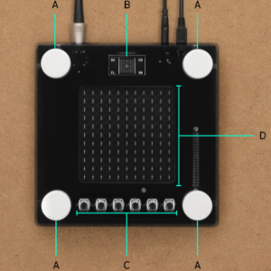](https://github.com/googlecreativelab/open-nsynth-super?utm_source=mybridge&utm_medium=blog&utm_campaign=read_more)](https://github.com/googlecreativelab/open-nsynth-super?utm_source=mybridge&utm_medium=blog&utm_campaign=read_more)

### [Rank 6](https://github.com/uber-common/deep-neuroevolution?utm_source=mybridge&utm_medium=blog&utm_campaign=read_more)

Deep-neuroevolution: Deep Neuroevolution **[573 stars on Github]**. Courtesy of [Uber](https://medium.com/@Uber)

[[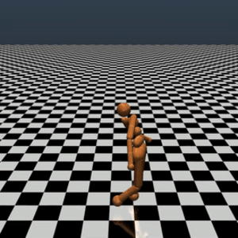](https://github.com/uber-common/deep-neuroevolution?utm_source=mybridge&utm_medium=blog&utm_campaign=read_more)](https://github.com/uber-common/deep-neuroevolution?utm_source=mybridge&utm_medium=blog&utm_campaign=read_more)

[……[Introducing Visual Inspector for Neuroevolution]](https://eng.uber.com/vine/)

### [Rank 7](https://github.com/minimaxir/person-blocker?utm_source=mybridge&utm_medium=blog&utm_campaign=read_more)

Person-blocker: Automatically “block” people in images (like Black Mirror) using a pretrained neural network. **[1533 stars on Github]**. Courtesy of [Max Woolf](https://medium.com/@minimaxir)

[[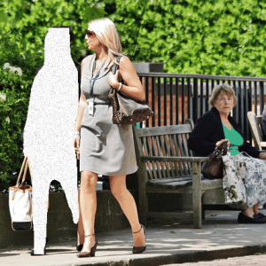](https://github.com/minimaxir/person-blocker?utm_source=mybridge&utm_medium=blog&utm_campaign=read_more)](https://github.com/minimaxir/person-blocker?utm_source=mybridge&utm_medium=blog&utm_campaign=read_more)

### [Rank 8](https://github.com/locuslab/TCN?utm_source=mybridge&utm_medium=blog&utm_campaign=read_more)

TCN: Sequence modeling benchmarks and temporal convolutional networks **[498 stars on Github]**. Courtesy of Zico Kolter

[[](https://github.com/locuslab/TCN?utm_source=mybridge&utm_medium=blog&utm_campaign=read_more)](https://github.com/locuslab/TCN?utm_source=mybridge&utm_medium=blog&utm_campaign=read_more)

### [Rank 9](https://github.com/Prodicode/ann-visualizer?utm_source=mybridge&utm_medium=blog&utm_campaign=read_more)

Ann-visualizer: A python library for visualizing Artificial Neural Networks (ANN) **[654 stars on Github]**. Courtesy of Prodi Code

[[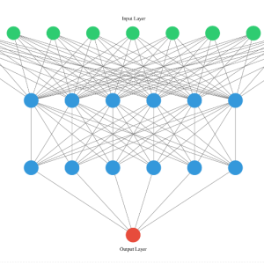](https://github.com/Prodicode/ann-visualizer?utm_source=mybridge&utm_medium=blog&utm_campaign=read_more)](https://github.com/Prodicode/ann-visualizer?utm_source=mybridge&utm_medium=blog&utm_campaign=read_more)

### [Rank 10](https://github.com/watson-developer-cloud/visual-recognition-coreml?utm_source=mybridge&utm_medium=blog&utm_campaign=read_more)

Visual-recognition-coreml: Classify images offline using Watson Visual Recognition and Core ML **[362 stars on Github]**. Courtesy of [IBM Watson](https://medium.com/@ibm.watson)

[[](https://github.com/watson-developer-cloud/visual-recognition-coreml?utm_source=mybridge&utm_medium=blog&utm_campaign=read_more)](https://github.com/watson-developer-cloud/visual-recognition-coreml?utm_source=mybridge&utm_medium=blog&utm_campaign=read_more)



That’s it for Machine Learning Monthly Open Source. If you like this curation, read best daily articles based on your programming skills on our [website.](http://mybridge.co/skills/machine-learning)

**Machine Learning Open Source of the Month (v.May 2018)**

For the past month**,** we ranked nearly 250 Machine Learning Open Source Projects to pick the Top 10.

We compared projects with new or major release during this period. [Mybridge AI](https://www.mybridge.co) ranks projects based on a variety of factors to measure its quality for professionals.

* Average number of Github stars in this edition: **979**⭐️
* “Watch” Machine Learning Top 10 Open Source on [**Github**](https://goo.gl/AwJT6Q) and get email once a month.
* Topics: ICLR 2018, Game Research, DeepLearn, Image Translation, Visualization, Text Generation, Self Driving Car, NLP, Video Loader

Open source projects can be useful for programmers. Hope you find an interesting project that inspires you.



**Course of the month:**

[**A) Beginners:** Data Science A-Z™: Real-Life Data Science Exercises Included.](http://bit.ly/2rsWwuu)*[11,909 recommends, 4.5/5 stars]*

[B**)** Deep Learning: Advanced Computer Vision.](http://bit.ly/2wq4Vnz) *[2,166 recommends, 4.7/5 stars]*



[**Rank 1**](https://github.com/tkarras/progressive_growing_of_gans?utm_source=mybridge&utm_medium=blog&utm_campaign=read_more)

Progressive\_growing\_of\_gans: Progressive Growing of GANs for Improved Quality, Stability, and Variation **[2523 stars on Github]**. Courtesy of Tero Karras

[[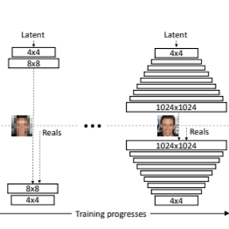](https://github.com/tkarras/progressive_growing_of_gans?utm_source=mybridge&utm_medium=blog&utm_campaign=read_more)](https://github.com/tkarras/progressive_growing_of_gans?utm_source=mybridge&utm_medium=blog&utm_campaign=read_more)

[……[Research Paper]](http://research.nvidia.com/publication/2017-10_Progressive-Growing-of)

[**Rank 2**](https://github.com/pytorch/elf?utm_source=mybridge&utm_medium=blog&utm_campaign=read_more)

ELF: An Extensive, Lightweight, and Flexible platform for game research. We have used it to build our Go playing bot, ELF OpenGo, which achieved a 14–0 record versus four global top-30 players **[1600 stars on Github]**. Courtesy of PyTorch

[[](https://github.com/pytorch/elf?utm_source=mybridge&utm_medium=blog&utm_campaign=read_more)](https://github.com/pytorch/elf?utm_source=mybridge&utm_medium=blog&utm_campaign=read_more)

[……[Facebook Open Sources ELF OpenGo]](https://research.fb.com/facebook-open-sources-elf-opengo/)

[**Rank 3**](https://github.com/GauravBh1010tt/DeepLearn?utm_source=mybridge&utm_medium=blog&utm_campaign=read_more)

DeepLearn: Implementation of research papers on Deep Learning+ NLP+ CV in Python using Keras, Tensorflow and Scikit Learn. **[1277 stars on Github]**. Courtesy of Gaurav Bhatt

[[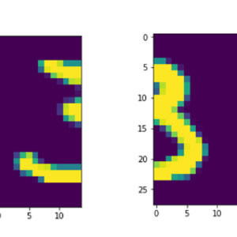](https://github.com/GauravBh1010tt/DeepLearn?utm_source=mybridge&utm_medium=blog&utm_campaign=read_more)](https://github.com/GauravBh1010tt/DeepLearn?utm_source=mybridge&utm_medium=blog&utm_campaign=read_more)

[**Rank 4**](https://github.com/NVlabs/MUNIT?utm_source=mybridge&utm_medium=blog&utm_campaign=read_more)

MUNIT: Multimodal Unsupervised Image-to-Image Translation **[813 stars on Github]**. Courtesy of NVIDIA Research

[[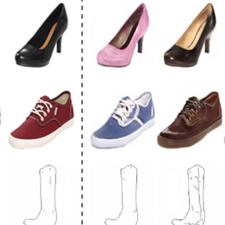](https://github.com/NVlabs/MUNIT?utm_source=mybridge&utm_medium=blog&utm_campaign=read_more)](https://github.com/NVlabs/MUNIT?utm_source=mybridge&utm_medium=blog&utm_campaign=read_more)

[……[Research Paper]](https://arxiv.org/abs/1804.04732)

[**Rank 5**](https://github.com/Microsoft/MMdnn?utm_source=mybridge&utm_medium=blog&utm_campaign=read_more)

MMdnn: A set of tools to help users inter-operate among different deep learning frameworks. E.g. model conversion and visualization. Convert models between Caffe, Keras, MXNet, Tensorflow **[1488 stars on Github]**. Courtesy of Microsoft Research

[[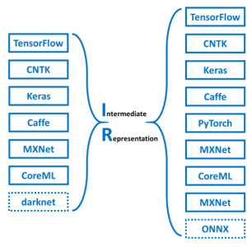](https://github.com/Microsoft/MMdnn?utm_source=mybridge&utm_medium=blog&utm_campaign=read_more)](https://github.com/Microsoft/MMdnn?utm_source=mybridge&utm_medium=blog&utm_campaign=read_more)

[**Rank 6**](https://github.com/minimaxir/textgenrnn?utm_source=mybridge&utm_medium=blog&utm_campaign=read_more)

Textgenrnn: Python module to easily generate text using a pretrained character-based recurrent neural network. **[620 stars on Github]**. Courtesy of [Max Woolf](https://medium.com/@minimaxir)

[[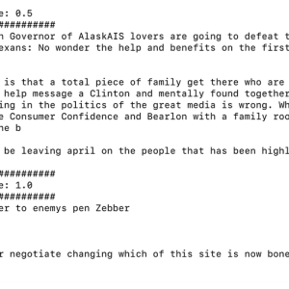](https://github.com/minimaxir/textgenrnn?utm_source=mybridge&utm_medium=blog&utm_campaign=read_more)](https://github.com/minimaxir/textgenrnn?utm_source=mybridge&utm_medium=blog&utm_campaign=read_more)

[**Rank 7**](https://github.com/wroscoe/donkey?utm_source=mybridge&utm_medium=blog&utm_campaign=read_more)

Donkey: A modular self driving car library for Python **[756 stars on Github]**. Courtesy of Will Roscoe

[[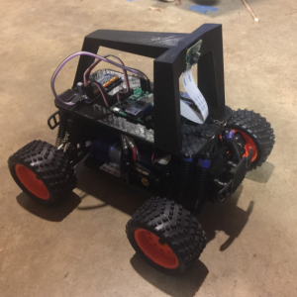](https://github.com/wroscoe/donkey?utm_source=mybridge&utm_medium=blog&utm_campaign=read_more)](https://github.com/wroscoe/donkey?utm_source=mybridge&utm_medium=blog&utm_campaign=read_more)

[**Rank 8**](https://github.com/jerryli27/TwinGAN?utm_source=mybridge&utm_medium=blog&utm_campaign=read_more)

TwinGAN: Unpaired Cross-Domain Image Translation with Weight-Sharing GANs **[234 stars on Github]**. Courtesy of Jerry Li

[[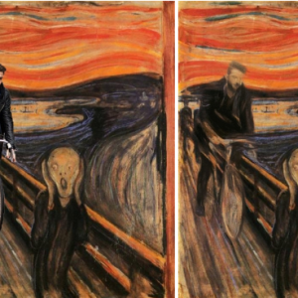](https://github.com/jerryli27/TwinGAN?utm_source=mybridge&utm_medium=blog&utm_campaign=read_more)](https://github.com/jerryli27/TwinGAN?utm_source=mybridge&utm_medium=blog&utm_campaign=read_more)

[**Rank 9**](https://github.com/dmlc/gluon-nlp?utm_source=mybridge&utm_medium=blog&utm_campaign=read_more)

Gluon-nlp: NLP made easy **[545 stars on Github]**. Courtesy of DMLC

[[](https://github.com/dmlc/gluon-nlp?utm_source=mybridge&utm_medium=blog&utm_campaign=read_more)](https://github.com/dmlc/gluon-nlp?utm_source=mybridge&utm_medium=blog&utm_campaign=read_more)

[**Rank 10**](https://github.com/NVIDIA/nvvl?utm_source=mybridge&utm_medium=blog&utm_campaign=read_more)

Nvvl: A library that uses hardware acceleration to load sequences of video frames to facilitate machine learning training **[294 stars on Github]**. Courtesy of NVIDIA

[[](https://github.com/NVIDIA/nvvl?utm_source=mybridge&utm_medium=blog&utm_campaign=read_more)](https://github.com/NVIDIA/nvvl?utm_source=mybridge&utm_medium=blog&utm_campaign=read_more)

[……[NVVL Accelerates Machine Learning on Video]](https://devblogs.nvidia.com/acclerate-machine-learnng-nvvl/)



That’s it for Machine Learning Top 10 Open Source of the Month. Visit our publication to find top posts for more programming skills.

# https://cdn-images-1.medium.com/max/2000/0*rEct7f1BbSHbl77d.jpgMachine Learning Open Source Projects of the Month (v.June 2018)

For the past month**,** we ranked nearly 250 Machine Learning Open Source Projects to pick the Top 10.

We compared projects with new or major release during this period. Mybridge AI ranks projects based on a variety of factors to measure its quality for professionals.

* Average number of Github stars in this edition: **764** ⭐️
* “Watch” Machine Learning Top 10 Open Source on [**Github**](https://goo.gl/AwJT6Q) and get email once a month.
* Topics: NLP Architect, Video Classification, Mlflow, Gym Retro, Dragonfire, Opencv, Computer vision, Star GAN, Glow, Generative compression

Open source projects can be useful for programmers. Hope you find an interesting project that inspires you.

**Course of the month:**

[**A) Beginners:** Python for Data Science and Machine Learning Bootcamp.](http://bit.ly/2Eso3R0)[21,763 recommends, 4.5/5 stars]

[B**) Advanced**: Artificial Intelligence: Reinforcement Learning in Python.](http://bit.ly/2HzWgyV)[1,768 recommends, 4.6/5 stars]



### [Rank 1](https://github.com/NervanaSystems/nlp-architect?utm_source=mybridge&utm_medium=blog&utm_campaign=read_more)

Nlp-architect: NLP Architect by Intel AI Lab: Python library for exploring the state-of-the-art deep learning topologies and techniques for NLP **[1194 stars on Github]**. Courtesy of Intel Nervana

[[](https://github.com/NervanaSystems/nlp-architect?utm_source=mybridge&utm_medium=blog&utm_campaign=read_more)](https://github.com/NervanaSystems/nlp-architect?utm_source=mybridge&utm_medium=blog&utm_campaign=read_more)

[……[Introducing NLP Architect by Intel AI Lab]](https://ai.intel.com/introducing-nlp-architect-by-intel-ai-lab/)

### [Rank 2](https://github.com/facebookresearch/video-nonlocal-net?utm_source=mybridge&utm_medium=blog&utm_campaign=read_more)

Video-nonlocal-net: Non-local Neural Networks for Video Classification **[592 stars on Github]**. Courtesy of [Facebook Research](https://medium.com/@FBResearch)

[[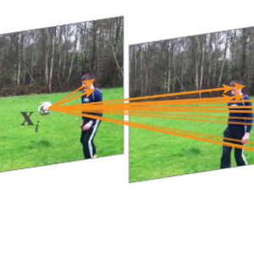](https://github.com/facebookresearch/video-nonlocal-net?utm_source=mybridge&utm_medium=blog&utm_campaign=read_more)](https://github.com/facebookresearch/video-nonlocal-net?utm_source=mybridge&utm_medium=blog&utm_campaign=read_more)

### [Rank 3](https://github.com/databricks/mlflow?utm_source=mybridge&utm_medium=blog&utm_campaign=read_more)

Mlflow: Open source platform for the complete machine learning lifecycle **[1282 stars on Github]**. Courtesy of [Databricks](https://medium.com/@databricks)

[[](https://github.com/databricks/mlflow?utm_source=mybridge&utm_medium=blog&utm_campaign=read_more)](https://github.com/databricks/mlflow?utm_source=mybridge&utm_medium=blog&utm_campaign=read_more)

### [Rank 4](https://github.com/openai/retro/tree/develop?utm_source=mybridge&utm_medium=blog&utm_campaign=read_more)

Retro: Retro Games in Gym **[905 stars on Github]**. Courtesy of OpenAI

[[](https://github.com/openai/retro/tree/develop?utm_source=mybridge&utm_medium=blog&utm_campaign=read_more)](https://github.com/openai/retro/tree/develop?utm_source=mybridge&utm_medium=blog&utm_campaign=read_more)

[……[ Introducing Gym Retro]](https://blog.openai.com/gym-retro/)

### [Rank 5](https://github.com/DragonComputer/Dragonfire?utm_source=mybridge&utm_medium=blog&utm_campaign=read_more)

Dragonfire v1.0: An open-source AI assistant for Ubuntu based Linux distributions **[688 stars on Github]**. Courtesy of DRAGON.COMPUTER

[[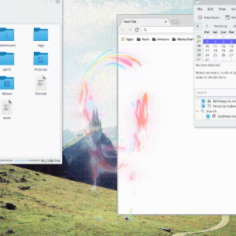](https://github.com/DragonComputer/Dragonfire?utm_source=mybridge&utm_medium=blog&utm_campaign=read_more)](https://github.com/DragonComputer/Dragonfire?utm_source=mybridge&utm_medium=blog&utm_campaign=read_more)

### [Rank 6](https://github.com/vipstone/faceai?utm_source=mybridge&utm_medium=blog&utm_campaign=read_more)

FaceAI: A face, video, text detection and recognition project (Use auto translator: Chinese -> English). **[1482 stars on Github]**.

[[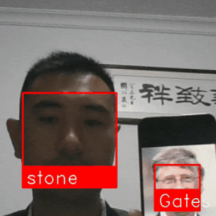](https://github.com/vipstone/faceai?utm_source=mybridge&utm_medium=blog&utm_campaign=read_more)](https://github.com/vipstone/faceai?utm_source=mybridge&utm_medium=blog&utm_campaign=read_more)

### [Rank 7](https://github.com/symisc/sod?utm_source=mybridge&utm_medium=blog&utm_campaign=read_more)

Sod: An Embedded Computer Vision & Machine Learning Library (CPU Optimized & IoT Capable) **[557 stars on Github]**. Courtesy of Symisc Systems

[[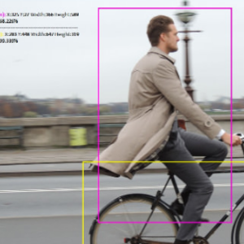](https://github.com/symisc/sod?utm_source=mybridge&utm_medium=blog&utm_campaign=read_more)](https://github.com/symisc/sod?utm_source=mybridge&utm_medium=blog&utm_campaign=read_more)

[……[Main Page]](https://sod.pixlab.io/)

### [Rank 8](https://github.com/taki0112/StarGAN-Tensorflow?utm_source=mybridge&utm_medium=blog&utm_campaign=read_more)

StarGAN-Tensorflow: Simple Tensorflow implementation of StarGAN (CVPR 2018 Oral) **[382 stars on Github]**. Courtesy of Junho Kim

[[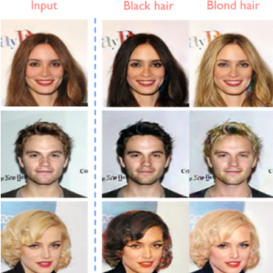](https://github.com/taki0112/StarGAN-Tensorflow?utm_source=mybridge&utm_medium=blog&utm_campaign=read_more)](https://github.com/taki0112/StarGAN-Tensorflow?utm_source=mybridge&utm_medium=blog&utm_campaign=read_more)

### [Rank 9](https://github.com/pytorch/glow?utm_source=mybridge&utm_medium=blog&utm_campaign=read_more)

Glow: Compiler for Neural Network hardware accelerators **[603 stars on Github]**. Courtesy of PyTorch

[[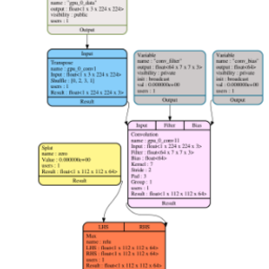](https://github.com/pytorch/glow?utm_source=mybridge&utm_medium=blog&utm_campaign=read_more)](https://github.com/pytorch/glow?utm_source=mybridge&utm_medium=blog&utm_campaign=read_more)

### [Rank 10](https://github.com/Justin-Tan/generative-compression?utm_source=mybridge&utm_medium=blog&utm_campaign=read_more)

Generative-compression: TensorFlow Implementation of Generative Adversarial Networks for Extreme Learned Image Compression **[225 stars on Github]**. Courtesy of Justin-Tan

[[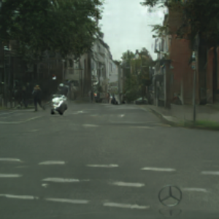](https://github.com/Justin-Tan/generative-compression?utm_source=mybridge&utm_medium=blog&utm_campaign=read_more)](https://github.com/Justin-Tan/generative-compression?utm_source=mybridge&utm_medium=blog&utm_campaign=read_more)

[](https://github.com/Justin-Tan/generative-compression?utm_source=mybridge&utm_medium=blog&utm_campaign=read_more)

# Machine Learning Open Source of the Month (v.July 2018)

For the past month**,** we ranked nearly 250 Machine Learning Open Source Projects to pick the Top 10.

We compared projects with new or major release during this period. Mybridge AI ranks projects based on a variety of factors to measure its quality for professionals.

* Average number of Github stars in this edition: **1,041**⭐️
* “Watch” Machine Learning Top 10 Open Source on [**Github**](https://goo.gl/AwJT6Q) and get email once a month.
* Topics: DensePose, Image Classification, Mulit-Scale Training, Mobile AI Compute Engine, Satellite Imagery, NLP, Python Package, Word detection, NCRF, DALI

Open source projects can be useful for programmers. Hope you find an interesting project that inspires you.

**Course of the month:**

[**A) Beginners:** Bayesian Machine Learning in Python: A/B Testing.](http://bit.ly/2KF1pv7) [1,037 recommends, 4.6/5 stars]

[B**)** Unsupervised Machine Learning Hidden Markov Models in Python.](http://bit.ly/2zfXQYb) [1,768 recommends, 4.6/5 stars]

### [Rank 1](https://github.com/facebookresearch/DensePose?utm_source=mybridge&utm_medium=blog&utm_campaign=read_more" \t "_blank)

DensePose: A real-time approach for mapping all human pixels of 2D RGB images to a 3D surface-based model of the body **[2901 stars on Github]**. Courtesy of [Facebook Research](https://medium.com/@FBResearch)

[[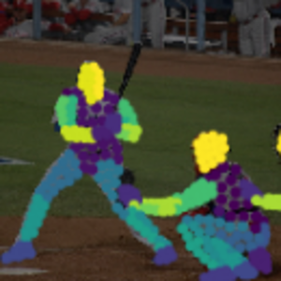](https://github.com/facebookresearch/DensePose?utm_source=mybridge&utm_medium=blog&utm_campaign=read_more)](https://github.com/facebookresearch/DensePose?utm_source=mybridge&utm_medium=blog&utm_campaign=read_more)

[……[Introducing DensePose]](https://research.fb.com/facebook-open-sources-densepose/)

### [Rank 2](https://github.com/quark0/darts?utm_source=mybridge&utm_medium=blog&utm_campaign=read_more)

Darts: Differentiable architecture search for convolutional and recurrent networks **[1128 stars on Github]**. Courtesy of Hanxiao Liu

[[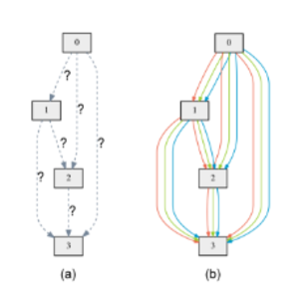](https://github.com/quark0/darts?utm_source=mybridge&utm_medium=blog&utm_campaign=read_more)](https://github.com/quark0/darts?utm_source=mybridge&utm_medium=blog&utm_campaign=read_more)

[……[Paper]](https://arxiv.org/abs/1806.09055)

### [Rank 3](https://github.com/mahyarnajibi/SNIPER?utm_source=mybridge&utm_medium=blog&utm_campaign=read_more)

SNIPER is an efficient multi-scale object detection algorithm **[1352 stars on Github]**. Courtesy of Mahyar Najibi

[[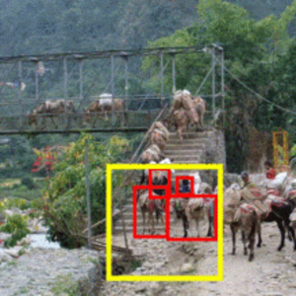](https://github.com/mahyarnajibi/SNIPER?utm_source=mybridge&utm_medium=blog&utm_campaign=read_more)](https://github.com/mahyarnajibi/SNIPER?utm_source=mybridge&utm_medium=blog&utm_campaign=read_more)

### [Rank 4](https://github.com/XiaoMi/mace?utm_source=mybridge&utm_medium=blog&utm_campaign=read_more)

Mace: A deep learning inference framework optimized for mobile heterogeneous computing platforms. **[2118 stars on Github]**. Courtesy of Xiaomi

[[](https://github.com/XiaoMi/mace?utm_source=mybridge&utm_medium=blog&utm_campaign=read_more)](https://github.com/XiaoMi/mace?utm_source=mybridge&utm_medium=blog&utm_campaign=read_more)

### [Rank 5](https://github.com/mapbox/robosat?utm_source=mybridge&utm_medium=blog&utm_campaign=read_more)

Robosat: Semantic segmentation on aerial and satellite imagery. Extracts features such as: buildings, parking lots, roads, water **[776 stars on Github]**. Courtesy of [Mapbox](https://medium.com/@Mapbox)

[[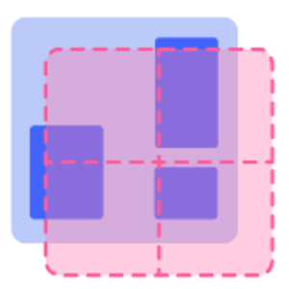](https://github.com/mapbox/robosat?utm_source=mybridge&utm_medium=blog&utm_campaign=read_more)](https://github.com/mapbox/robosat?utm_source=mybridge&utm_medium=blog&utm_campaign=read_more)

### [Rank 6](https://github.com/salesforce/decaNLP?utm_source=mybridge&utm_medium=blog&utm_campaign=read_more)

DecaNLP: The Natural Language Decathlon: A Multitask Challenge for NLP — Salesforce **[886 stars on Github]**. Courtesy of [Salesforce](https://medium.com/@salesforce)

[[](https://github.com/salesforce/decaNLP?utm_source=mybridge&utm_medium=blog&utm_campaign=read_more)](https://github.com/salesforce/decaNLP?utm_source=mybridge&utm_medium=blog&utm_campaign=read_more)

### [Rank 7](https://github.com/plasticityai/magnitude?utm_source=mybridge&utm_medium=blog&utm_campaign=read_more)

Magnitude: A fast, efficient universal vector embedding utility package. **[427 stars on Github]**. Courtesy of Plasticity

[[](https://github.com/plasticityai/magnitude?utm_source=mybridge&utm_medium=blog&utm_campaign=read_more)](https://github.com/plasticityai/magnitude?utm_source=mybridge&utm_medium=blog&utm_campaign=read_more)

### [Rank 8](https://github.com/Picovoice/Porcupine?utm_source=mybridge&utm_medium=blog&utm_campaign=read_more)

Porcupine: On-device wake word detection engine powered by deep learning. **[373 stars on Github]**. Courtesy of Picovoice

[[](https://github.com/Picovoice/Porcupine?utm_source=mybridge&utm_medium=blog&utm_campaign=read_more)](https://github.com/Picovoice/Porcupine?utm_source=mybridge&utm_medium=blog&utm_campaign=read_more)

### [Rank 9](https://github.com/baidu-research/NCRF?utm_source=mybridge&utm_medium=blog&utm_campaign=read_more)

Cancer metastasis detection with neural conditional random field (NCRF) **[290 stars on Github]**. Courtesy of baidu-research

[[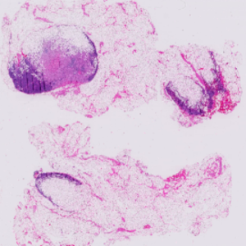](https://github.com/baidu-research/NCRF?utm_source=mybridge&utm_medium=blog&utm_campaign=read_more)](https://github.com/baidu-research/NCRF?utm_source=mybridge&utm_medium=blog&utm_campaign=read_more)

### [Rank 10](https://github.com/NVIDIA/dali?utm_source=mybridge&utm_medium=blog&utm_campaign=read_more)

DALI: A library containing both highly optimized building blocks and an execution engine for data pre-processing in deep learning applications **[420 stars on Github]**. Courtesy of NVIDIA

[[](https://github.com/NVIDIA/dali?utm_source=mybridge&utm_medium=blog&utm_campaign=read_more)](https://github.com/NVIDIA/dali?utm_source=mybridge&utm_medium=blog&utm_campaign=read_more)

[](https://github.com/NVIDIA/dali?utm_source=mybridge&utm_medium=blog&utm_campaign=read_more)